(As of 14 April 2022)

WFP Madagascar
Cyclone Response Update

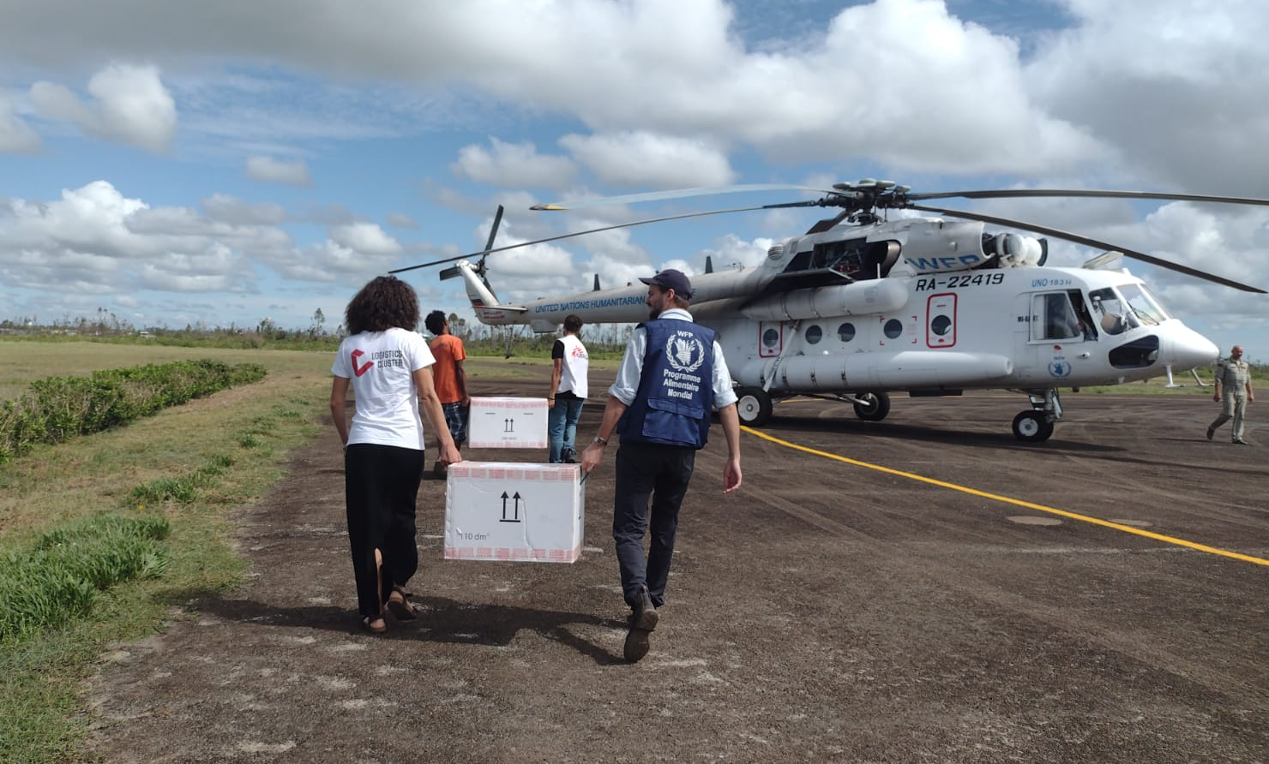

Humanitarian cargo for the emergency cyclone response being loaded into the WFP UNHAS MI-8 helicopter at the airport in Mananjary, Madagascar. Photo: WFP/Carlotta Negri

Highlights

- WFP has assisted 372,040 people who have been affected by the recent tropical cyclones and storms that have hit Madagascar since January through its first round of general food and unconditional cash distributions. WFP has begun its second round of distributions as it works to complete its first round of distributions, reaching 11,335 people to date.
WFP Madagascar Cyclone Response (as of 14 April 2022)
General Food Distributions | First Round | Second Round | Third Round
Planned | 166,470 | 134,270 | 92,450
Reached | 122,085 | 11,335
% of Planned | 73% | 8%
Unconditional Cash Distributions | First Round | Second Round | Third Round
Planned | 293,100 | 285,440 | 327,260
Reached | 247,955 | 0
% of Planned | 85% | 0%
Total GFD beneficiaries planned | 459,570 | 419,710 | 419,710
Total GFD beneficiaries reached | 370,040 | 11,335
*WFP expects to shift a portion of its planned caseload from food to cash as markets affected by the cyclones and storms begin to recover.
1,085 MT of food distributed | USD 1.2 million of cash distributed

Situation overview

- Between January and March 2022, Madagascar was hit by five storms and tropical cyclones (Ana, Batsirai, Dumako, Emnati, and Gombo) that caused considerable damage. Climate change made extreme rainfall heavier and more damaging, according to rapid attribution analysis by an international team of climate scientists as part of the World Weather Attribution group.
- In total, more than 960,000 persons have been affected by the storms and tropical cyclones that hit Madagascar since January. At least 470,000 people are in urgent need of food assistance in Vatovavy, Fitovinany, and Atsimo Atsinanana regions according to the latest estimate established by the National Office of Risk and Disaster Management (BNGRC) after the passage of Cyclones Batsirai and Emnati.
- Cyclones Batsirai and Emnati caused significant crop and infrastructure damage, including the severe flooding of 60,000 hectares of rice fields, which will likely reduce Madagascar’s local rice production by more than 40 percent according to the Famine Early Warning Systems Network. Tropical Storm Ana damaged a further 35,000 hectares of rice and 6,500 hectares of maize in the central prime land around Antananarivo.

Latest updates on WFP response
- As of 14 April, WFP has assisted 370,040 people who have been affected by the recent tropical cyclones and storms that have hit Madagascar since January through its first round of general food and unconditional cash distributions. Of these, 247,955 people have received cash assistance and 122,085 people have received food assistance.
- Massive landslides caused by the tropical cyclones and storms left much of the district of Midongy-Atsimo with limited or no road access, disrupting WFP’s first round of general food assistance to the district. Thanks to a WFP food assistance-for-assets (FFA) project supporting 400 vulnerable men and women, the main road to the district has been partially reopened but remains in extremely poor condition, enabling the first delivery of 10 MT of food as of 14 April.
- First-round general food and unconditional cash distributions are also planned or ongoing in newly targeted, cyclone-affected communities in rural, hard-to-reach areas in the districts of Anosibe An’ala, Mahanoro, Marolambo, Ikongo, and Nosy Varika.
- WFP is implementing additional FFA projects to rehabilitate roads affected by the storms and cyclones in the district of Antanambao Manampotsy and to clear drainage canals blocked by Tropical Storm Ana in the city of Antananarivo, targeting to assist 13,100 people. WFP is continuing to identify additional FFA projects to support early recovery from the cyclones in coordination with the Government and local authorities.
- WFP has begun its second round of general food and cash distributions as it works to also complete its first round of distributions, reaching 11,335 people as of 14 April. Second-round general food distributions have been completed in the communes of Ambohimiarina II, Marofody, and Tsaravary in the district of Mananjary. WFP’s beneficiary target for its second and third round of general food and unconditional cash distributions stands at 419,710 people.
- WFP is planning to implement a “cash for shelter” project to support vulnerable households who had their homes completely or partially destroyed by the cyclones. WFP plans to provide 7,305 households or 36,525 people with cash-based transfers to enable them to rehabilitate and reconstruct their homes.

Humanitarian response

- The United Nations Humanitarian Air Service (UNHAS), managed by WFP, continues to transport humanitarian passengers and cargo from Antananarivo to the cyclone-affected cities of Mananjary and Manakara in eastern Madagascar. EU Humanitarian Aid flights, financed by ECHO and managed by WFP/UNHAS are also operating to facilitate travel between Antananarivo and Mananjary, Manakara, and Farafangana, with current funding allowing flights until 03 June.
- The Government’s Intervention Fund for Development (FID) is working with Cash Working Group partners including WFP, the Malagasy Red Cross, and Save the Children to harmonize cash-based approaches and assist the hardest-hit people in eight affected regions.
- Education partners including UNICEF are working with the Ministry of Education to rehabilitate schools damaged by cyclones by repairing damaged roofs, installing temporary classrooms, and providing education materials.
- Health partners are collaborating to rehabilitate health centres and deliver health services, providing reproductive health products and medical equipment, installing a temporary maternity ward, and distributing vaccines.
- The National Office for Nutrition has distributed 10,600 kilos of enriched flour to mothers in Mananjary and Manakara districts, and over 3,300 Ready-to-Use Therapeutic Food (RUTF) Plumpy Nut packets.
- Shelter partners such as CARE, the Red Cross, Médecins du Monde, and IOM are supporting families sheltered in temporary displacement sites and assisting them in returning home, distributing kitchen sets, shelter kits, and providing psychological support to displaced families.
- Water, sanitation and hygiene (WASH) partners have resumed the provision of water to communities affected by the cyclones, setting up water production units, distributing WASH kits, and purifying wells that were contaminated during the cyclones.
- Protection partners, including UNICEF, UNFPA, and CRS are raising awareness on the prevention of sexual exploitation and abuse, distributing dignity kits for survivors of gender-based violence and providing psychosocial support.
Sources: WFP, BNGRC, OCHA, FEWS NET, World Meteorological Organization.

For more information please contact:

- WFP Madagascar Country Director and Representative: pasqualina.disirio@wfp.org
- WFP Madagascar Deputy Country Director: arduino.mangoni@wfp.org
- UNHAS Madagascar - Chief Air Transport Officer: nejmeddine.halfaoui@wfp.org
- WFP Madagascar Partnerships Officer: julia.ross@wfp.org
- WFP Madagascar Communications Officer: alice.rahmoun@wfp.org

