WFP—FAO Joint Workshop
Refugee-influx Emergency Vulnerability Assessment 6/ Resilience Index Measurement and Analysis 2/ Food Security Outcome Monitoring
3-4 October 2022
Venue: Sea Palace Hotel, Cox’s Bazar

Agenda

Overall objectives

- Potential use of the REVA/RIMA data in the government programme/policy design.
- A stronger linkage between the government and Humanitarian development actors in the Food Security area.

The workshop was held to inform the REVA and RIMA of the central government and how they can be utilised in government capacity strengthening. Ms. Jessica Kim, WFP and Mr. Imtiaz Ahmed, FAO inogorated the workshop. Mr. Mohammad Maniul Hossain Rony, FSC coordinator has facilitated the workshop.
After the historical results of REVA/RIMA, and the upcoming plan for the joint REVA/RIMA data collection in October 2022, the participants discussed and came up with the below recommedations.

Key recommendations from the workshop:

- Participants appreciated the approach of government engagement and recommended disseminating the findings timely at the district level with the National level presence, as well as national level dissemination to address the national level programming.
- BBS has district-level data also subdistrict level data from the Census and in some surveys. But as this REVA and RIMA survey is planned for a regular interval, this represents sub-district level time series data which will be very much helpful for the different programmes and projects of the government and other actors by complementing the official statistics.
- This joint survey results will help the government, other humanitarian, and development actors to make informed decisions for Cox’s Bazar district.
- Sometimes information is shared at the national level but at the district level who are the implementor knows nothing about it and vice versa.
- Reports should be shared with the government’s active participation and no need to go through the approval process as that will be time-consuming and may lose neutrality.
- It would be good if the methodology and questionnaire are shared with the SAG members for active participation.
- Link government plans and policies with the findings and recommendations.
- Discuss the probability of Agriculture in an Emergency working group at the national level.
- Government highly appreciated the inclusion of early warning and early action in the FSS objective.
- Proposed to scale up the assessment at the national level at least with a few disaster-prone districts.
- Consultation/consensus building to ensure active government participation instead of approval, cross visit, cluster approach, JRP, Joint Implementation Plan.
- There should be clear monitoring tools and periodic discussions with various stakeholders.
- Finally, it’s a clear go-ahead from the government participants.

Field visit observations and recommendations:

- As the aggregation centre is a good model, more linkage for the government is encouraged for sustainability. Also, particularly, areas of livestock, and fishery can be integrated into this model through government support. The agriculture information service from the government should be informed
- FAO-supported Aggregation Centre is operating with the engagement of Government line departments and private sector entities. It is registered from the Cooperative department & office space donated by a member). FAO leaded AC model should be recommended for further evaluation to observe the sustainability and replication nationwide.
- The aggregation centre model is to be replicated in other parts of the country
- The visit team appreciated to support farmers/households on different agricultural apps (door to door) through Digital Service Providers (DSP) with the attachment of Aggregation Centre. It should be well linked with Union digital service center.

- As per WFP’s food assistance, pregnant and lactating women, and children under 5 are most food insecure. To improve their nutritional intake, behavior change for food choice to meet their nutrition needs.
- For the cyclone centre, in the event of floods, the water level could go beyond the ground floor. Therefore, the centres need to be disability friendly and need to consider. Also, a protection safeguarding mechanism needs to be established during the disaster.
- Considering the school snacks' plastic waste, a better linkage with the recycling centre needs to be established for better solid waste management.
- Robust price monitoring and information management system for the production farmer
- Policy dialogue to see how to highlight the government subsidy for Rohingya response.
- The collection of native variety seed like Pterygota alata, Pterocarpus indicus in the seed treatment centre as well as equipment provided from FAO like humidity analyser, seed dryer oven in the seed treatment centre at FAO supported government owned nursery in Dhoapalong Range was much appreciated.

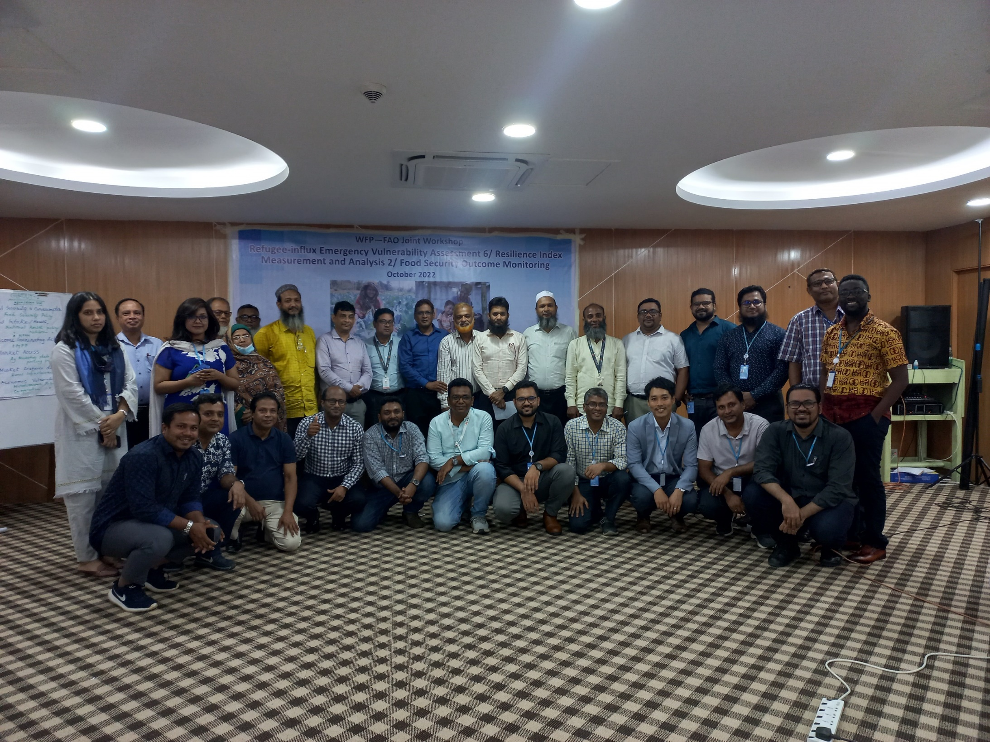

Mission Participants (16):

 | Name | Organization | Designation | Note
1 | Md. Mahbubur Rahman | Food Planning and Monitoring Unit (FPMU), Ministry of Food | Research Director | DAC
2 | Md. Raza Mia | Ministry of Labour and Employment | Deputy Secretary | DAC
3 | Ms. Shaleha Khatun | Bangladesh Bureau of Statistics, Ministry of Planning | Joint Director | DAC
4 | Md Abdul Halim | Bangladesh Bureau of Statistics, Ministry of Planning | Joint Director | DAC
5 | Dr. Taufiqur Rahman | Department of Agriculture Extension, Ministry of Agriculture | Senior Production Economist (Deputy Director) | DAC
6 | Humayun Kobir | Department of Agriculture Extension, Ministry of Agriculture | Agriculture Officer | DAC
7 | Dr. Maniruzzaman | Institute of Public Health and Nutrition (IPHN), Ministry of Health and Family Planning | Programme Manager | DAC
8 | Syed Ashraf UL Islam | Department of Disaster Management, Ministry of Disaster Management and Relief | Communication and Media Specialist | DAC
9 | Md Jashim Uddin | Department of Livestock Services (DLS), Ministry of Livestock and Fisheries | Sub Assistant - Livestock Officer | DAC
10 | Mr. Sarwar Alam | Bangladesh Forest Department | Divisional Forest Officer, South Forest Division | CXB
11 | Dr. Arif Hasnat | Department of Livestock Services | District Livestock Officer | CXB
12 | Md. Kabir Hossain | Department of Agricultural Extension | Deputy Director. | CXB
13 | Md. Boduruzaman | Department of Fisheries. | District Fisheries Officer | CXB
14 | Mehedi Hasan Shishir | International Federation of Red Cross and Red Crescent Societies (IFRC) | Manager, Livelihood & Cash | DAC
15 | Md. Rajab Ali | World Vision Bangladesh | Chief of Party | CXB
16 | Mr. Anit Mishra | Shushilon (NGO) | Advisor | CXB
Annex 1
Day 1 (Monday, 3 October 2022) : Workshop

Time | Topics | Facilitator
10:00 - 10:15  (15 min) | Registration | FSS team
10:15 – 10:30  (15 min) | Welcome and opening remark | WFP/FAO/FSC
10:30 – 10:40  (10 min) | Representative of the SAG member | Mahbub (FPMU)
10:40 – 11:10  (30 min) | Introduction of REVA/FSOM and its historical results | Taka – WFP
11:10 - 11:25  (15 min) | Coffee break
11:25 – 12:00  (35 min) | Introduction of RIMA and its results of 2021 survey | Maruf - FAO
12:00 – 12:15  (15 min) | Q&A
12:15 – 12:30 (15 min) | FSC/FSS coordination mechanism | FSC/FSS
12:30 – 13:00  (30 min) | Presentation of upcoming joint assessment | WFP/FAO
13:00 – 13:30  (30 min) | Q&A
13:30 - 14:30  (60 min) | Lunch break
14:30– 15:10  (40 min) | Programme Overview in Cox’s Bazar | WFP/FAO
15:10- 15:40  (30 min) | Discussion:  - Potential use of the REVA/RIMA data in the government programme/policy design.  - Stronger linkage between the government and Humanitarian development actors in the Food Security area. | FSC - Coordinator
15:40- 16:00  (20 min) | Closing remarks from WFP  Closing Remarks from FAO  Closing Remarks from FSS/FSC

Day 2 (Tuesday, 4 October 2022): Field visit and FSC SAG Meeting

Time | Activity | Notes
08:00 – 9:00  (60 min) | Drive from Cox’s Bazar to Ukhiya
9:00 – 9:30  (30 min) | Visit Primary School/ Multi-purpose cyclone shelter  Monkhali Govt. Primary School, Jaliapalong | WFP  GPS: 21.0913, 92.1299
9:30 – 9:50  (20 min) | Drive to next location
9:50 – 10:40  (50 min) | Lombagona aggregation centre  Interact with members and livestock group | WFP  GPS: 21.11286, 92.17214
10:40-11:00  (20 min) | Drive to next location
11:00-11:30  (30 min) | WFP e-voucher shop at Camp 21, Chakmakul | WFP  GPS: 21.1063,92.1989
11:30-12:15  (45 min) | Drive to next location
12:15 – 13:15  (60 min) | Lunch at Modhurchar Logistics Hub | WFP  GPS: 21.09137,92.21131
13:15-13:45  (30 min) | Drive to next location
13:45-14:30  (45 min) | Digital village (Tolatoli)  Ratnapalong, Moricha Bazar, Ratna Palong Union  Interact with farmer group | FAO  GPS: 21.287919, 92.15569
14:30-15:00  (30 min) | Drive to next location
15:00-15:45  (45 min) | Government-owned Dhoapalong Range Nursery, Khuniapalong Union Tulatoli, Ramu, Cox’s Bazar  Interact with nursery management team | FAO
15:45-16:30  (45 min) | Travel back to Cox’s Bazar
16:30 | Reach to Cox’s Bazar sadar
17:00 – 18:30 | Food Security Cluster Strategic Advisory Group (SAG) meeting | Only SAG members from Dhaka

