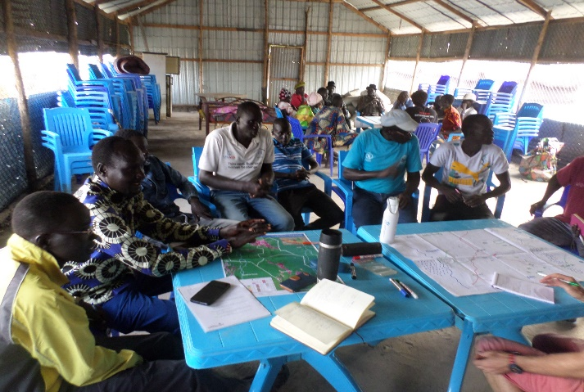**Draft report based on findings from FSLC & REACH Leer & Mayendit mission 4th – 14th June 2021**:

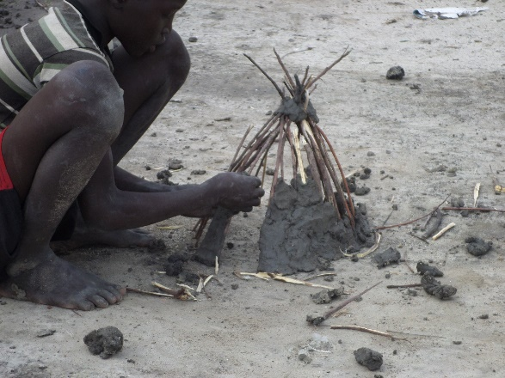

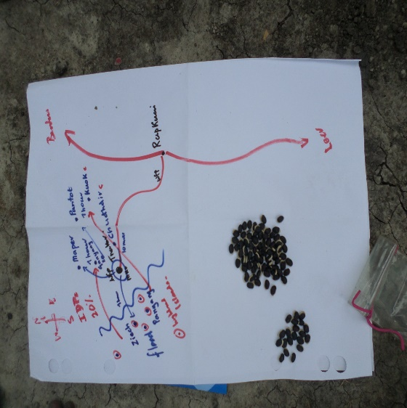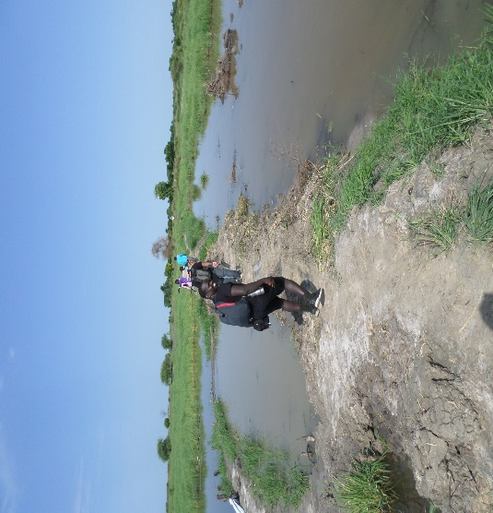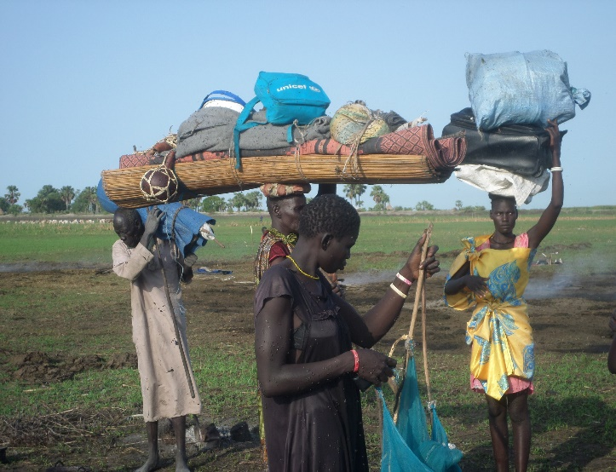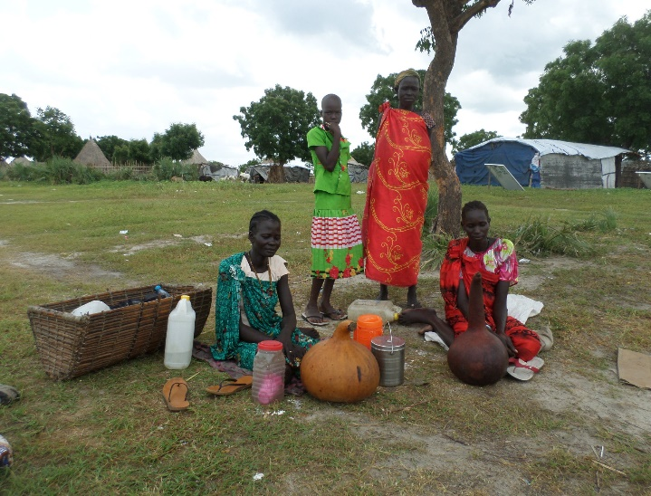

**Objectives: (**1) change over time and underlying issues for sustainable livelihoods; and (2) the extent of service delivery and functionality across the two counties;

**Background:**

Alex – provides the INT data suggesting locations at risk/ concern based on key indicators;

See annex 1 for the 11 day itinerary;

Since January 2017 there have been 9 IPC analyses: Leer has experienced one famine declaration, three emergency phase 4 and five crisis phase 3 levels of food insecurity: improving since 2017; whilst Mayendit has experienced six emergency phase 4 and three crisis phase 3 levels of food insecurity and deteriorating. Leer county has 70% of the population in IPC phase 3+ (53,000) and Mayendit with 75% in IPC phase 3+ (52,000). Both counties have significant proportions of their populations who are highly food insecure as evidenced in more detail later in this report. Additionally both counties have similar unmet needs or gaps with an estimated 10 – 13,000 persons in IPC3+ not receiving food assistance and 30 – 39,000 persons not receiving livelihood support further compounding the food security of a highly vulnerable population. See annex 2 for the trend, gap and IPC ranking analysis data sets for counties in Unity State.

There is a general consensus across the two counties that the forthcoming period May – July (lean season) with a possible third year of flooding is going to be very tough. Harvested maize is expected in September and sorghum later (if there is no flooding again!). But in large parts of especially Mayendit, cultivation is limited to around the homestead (all HHs very active when not fixing dykes) with planned cultivation expected to be only 20% of the ‘planned normal area of cultivation’. This is also anticipated to be a challenge across parts of southern and western Leer.

**Worst hunger**:

|  |  |  |  |
| --- | --- | --- | --- |
| **Hunger period** | **Adok (Leer)** | **Touchriak (Leer)** | **Dabluai (Mayendit)** |
| **1988 drought but some cattle alive** | reliance on ….. ‘name of leaves’; drought; #1 **0/10** but none had experienced this time themselves only told about it; | Drought but some animals alive; | Worse than today |
| **1997 inter Nuer** | -not mentioned | Conflict between Nuer commanders; took animals | Better than today: surplus food production in Rubkona (exchange cows for grains) |
| **Pre crisis circa 2011/ 2012** |  | Animals, milk, low market prices, 3 meals per day **10/10**; |  |
| **2014 – 2015 crisis** | identified as worst (Adok) – # 2 score **0/10** | War; kill you; take your daughters & animals; **0/10** |  |
| **2016 – 2017 crisis** | hunger but UN food - # 3 score **2/10** | UN dropped food |  |
| **2018 SPLA final push** | Seen by NGOs as very severe: rape, killing to remove iO from central Unity (SP) | | Houses burnt, ran for their lives; **worse than today** |
| **Now hunger in 2021** | Score **4/10** | Some hunger deaths known **5/10** |  |

Groups of primary (community members) and secondary (NGO, Chiefs & local authority) stakeholders gave perceptions of the current lean season hunger. The current hunger is not perceived to be as bad as that of 1988 (caused by drought and scored 0/10[1]) or at the peak of the crisis, reported to be late 2015 and mid 2018 (score 0/10) when the SPLA and Youth militias from Koch, Mayom, Guit and Rubkona destroyed homes, stole property especially cattle, raped, killed and committed horrific human rights violations (as reported by Amnesty International, 2018); and the famine declaration period 2016/ 2017 (2/10). However the current hunger in 2021 is worse than the 1997 hunger, during the war between the Nuer commanders, and scored as 4/10 and corroborated by community members in Touchriak (Leer) and Dabluai (Mayendit) with a score of 5/10 in comparison to the worst hungers identified. The pressure of hunger has been exacerbated by the returnees and flood affected IDPs without any commensurate increase in HFA; the mission came across two instances of reported hunger deaths in 2021 from Thonyor (Leer) being an IDP from Panyijar and a returnee from Bentui.

**Timelines & context**:

* The assessment took a longitudinal approach to assess livelihoods (including basic services: WASH, Health & Nutrition) over space (mapping) and time, using three historic periods: pre crisis circa 2011/ 2012, the peak crisis late 2013 to 2018 and the current crisis today 2021. Please note the local community perception that *‘the crisis has reduced (since the peak) but is, most certainly, not over*’.
* The **pre crisis** period around independence was seen as a time of plenty; people generally ate three meals a day; many households had animals and some had very many with thriving livestock trade selling animals to Sudan and Juba; businesses prospered; there was free movement & free speech; they didn’t have enemies; homesteads were peaceful; but there was some raiding in the cattle camps; Leer town had the second biggest market in Unity State after Bentui; and the population was far larger than today estimated at 140 – 170,000.
* The **worst of the crisis** many people fled (55%+/-) especially those with resources (Rich and Middle group members) who fled overseas (Ethiopia, Sudan, Uganda, Kenya to refugee camps and to where they had family); others fled to Juba and the POCs in Juba and Bentui; and an unknow number, albeit ‘many’ were killed (unconfirmed estimates 10 – 20,000). Those who remained (45%+/-) at the height of successive waves of SPLA & Youth militia and Darfuri mercenary attacks fled: most to islands along the River Nile whilst others to the nearby bush/ forest; many also were killed during these attacks, died of hunger or disease related illnesses. People fished, lived mainly on wild foods and when possible on HFA.
* **Today the crisis continues** despite the loss assets and loss of family labor (died or yet to return); families are split and fragmented: one man returned with his wife; another wife remains in Juba POC; and a third is in Uganda where their focus is on safety and securing an education for their children. There remains a high degree of uncertainty as the SPLA troops involved in the human rights violations in the depth of the crisis remain in Leer County, albeit the new Commissioner has sent them off the streets of Leer town. Many have returned since the peace agreement (October 2018) and there are many IDPs since the 2020 flooding mainly from south Mayendit but also from Panyijar.

**Mapping the contextual changes** (see mapping of spatial changes):

Annex 3 provides a brief summary of the two main livelihood zones across the two counties: (1) the north western flood plain sorghum & cattle; and (2) the Nile basin fishing & agro pastoral zones;

* The main **population (density)** is still found an area either side of the north – south main road from Adok and up into Koch County heading to Bentui; this forms the main upland ridge for permanent homesteads;
* Vast areas of Leer and Mayendit counties remain unpopulated and covered in marshes (*toic)*; **farming** initially expanded but in 2020 has been restricted by the flood waters that remain; 51 *highland – islands,* cut off by the floods are identified where small patches of cultivation take place in the marginal flood affected areas;
* The pre crisis **livestock** trade routes have yet to be revived[2] as all but an estimated <10% of livestock remained at the height of the crisis; indigenous restocking is taking place through dowry (daughters in POC marrying from Koch, Guit, Rubkona & Mayom), some purchases and natural growth; VSF estimate the livestock population could be 20 – 30% of the pre crisis level of approximately 300,000, possibly 80 – 100,000 animals now;

**Map to show the context & spatial changes: flooding, dykes, livestock movement, livestock trade (pre crisis) across the two counties**

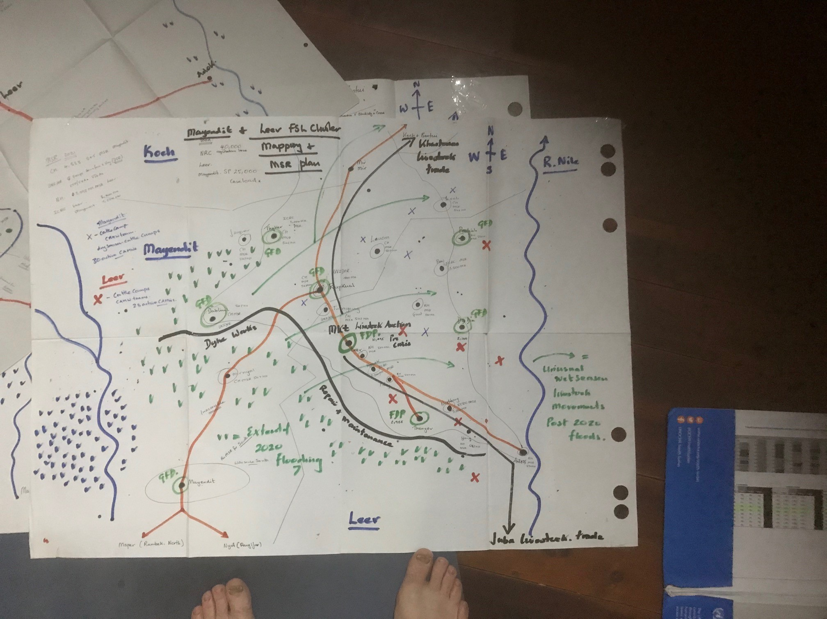

* **Fishing** is not widely practiced except along the River Nile and in other inland river systems; populations lack the equipment: boats, nets and hooks to take advantage of the river fish that have entered the swamp during the floods;
* **Flooding** has spread across large areas of Southern and Western Mayendit and into the Western territories of Leer;
* There is **active dyke maintenance** running from Adok (north westerly) through Leer and swings west into Mayendit along routes to Dabluai and Thakker; as a barrier to the main flood source from (1) rains and primarily (2) from Panyijar swamps and the R. Nile overflow;
* The **floods** exacted an extra disease burden on livestock, loss of grazing/ forage due to the standing water; quarterly stocks run out and pipeline breaks in vaccine & veterinary medicines; this has resulted in increased livestock disease, morbidity (the current FMD[3] outbreak is reducing milk production by 70%);
* As a consequence wet season **livestock migration** has shifted to cattle camps in the north and east of Mayendit & Leer and further into Koch; the source of milk at the height of the lean season ,is far from the children in the homesteads, along side the elderly and pregnant & lactating women who need it most but unable to access it in sufficient quantity;
* **Markets** have partially revived especially in Adok (a major supply route linking with Malakal and Juba along the River Nile: bringing cereals, clothes, shoes and other food stuffs; along with the **high prices** associated with the macro economic crisis and currency devaluation in the past six years;

Alex – anything more on livestock from our Friday morning at the cattle camp (as you took the notes)?

**Social group analysis & change over time**: *(proportions generated by % piling & illustrated below)*

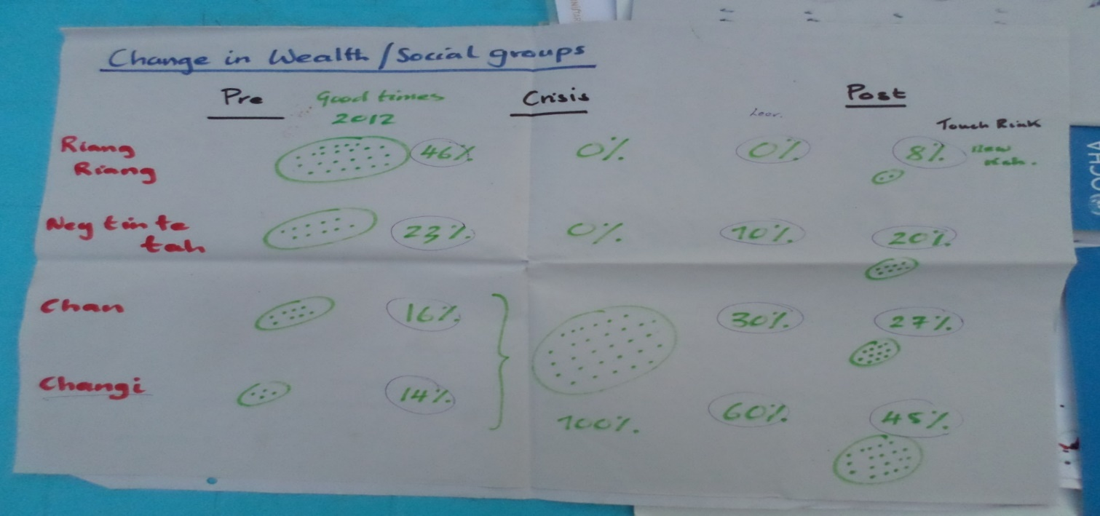

|  |  |  |  |
| --- | --- | --- | --- |
| **Pre crisis situation circa 2012**  **Population approx... 130,000[4]** | **During the worst hunger 2015/ 2016/ 2018**  **Approx. 50,000** | **Situation today 2021**  **Approx. 80,000** | **Situation today 2021**  **Women FGD Touchriak** |
| **Rich:** riang riang 47%  Characteristics: 60 – 70 cattle even 100+ up to 500; goats 100+ up to 200 (not really considered)  With money, Government job, salary; sale of bulls; booming business: clothes & commodities; Leer #2 shopping center in Unity; multiple houses, multiple wife & farms: 5 – 10 bags sorghum per farm (some up to 10 wives); large families with labor; connections & family across SSD & overseas; | **Rich**: 0%  Lost cows; caught by surprise; shops & assets in Leer looted; but good coping: education, investments & family in country/ world wide; networks ‘large families in places’ and ‘children already outside the country’; big psychological effect to lose ‘everything’; 2 – 3 years wave of repetitive looting; **25% killed (trauma/ psychological);** 14% dropped to chan; 17% left country & 40% left for other parts of SSD. | **Rich**: 0%  New people rich but not like before; market traders Darfur, Ugandan & Nuer;  Population unsure: those moving back & forth (split families) from POC;  Stakeholders estimate approx... 16 – 20% spontaneous returns (see context on day 1) | **Rich:** 8%  Some have 10 cows & invested in the fencing export business in Adok;  Many from Leer moved to Touch riak where they remain today as fear of SPLA in Leer; |

**Riang riang** the rich: the largest pre crisis social group (almost 50%) with large livestock holdings, large families, large farms, invested in business and family connections across the country & overseas; they provided employment, supported relatives and instrumental in an effective community support mechanism for the poor groups e.g. providing milk or a lactating cow, money or sorghum etc. resource rich at the start of the crisis many able then to flee to refugee camps or POCs and to Sudan; suggested many killed; assets in Unity stripped, looted and destroyed; today rich are ‘not like before’ with few livestock (more than others); many restarted business around trading fencing materials exported through Adok;

|  |  |  |  |
| --- | --- | --- | --- |
| **Middle**: ney tin te tah 23%  Cows 10 – 15; goats 15 – 20; businesses, charcoal, shop, fishing, good farm: 3 – 5 bags (1 bag seed other last for 3 – 4 months); fewer wives; | **Middle**: 0%  As with rich some left country or displaced to POC; most fled to the islands; having lost their assets; Some with means found a way out e.g. bought a fishing hook (to fish); travelled to Nyal & onto Juba; and some killed; | **Middle**: New rich 10%  Cows 3 – 5; business: market, fishing (fisher folk climb up the ladder) & transport; money, resources, eating beyond HFA; children remaining in POC (Chief: education); NGO workers with salaries: big pressure to share with relatives; children also away (Juba/ POC/ Uganda etc.); Pre crisis 40 NGOs; today only 14; | **Middle:** 20%  1 – 2 cows; plus farm & goats;  Both rich & middle now have very little to share with their chan & changi relatives & neighbors; |

**Ney tin te tah** the middle: pre crisis almost 25%; less well resourced than the rich but with ample assets to meet family, relative and community obligations and with aspirations to advance; hit in the same way as the rich during the wave of attacks during the crisis: lost all assets, some killed, some able to flee; as with the rich any who stayed became poor; today the ‘green shoots’ of growth: business, few animals (restocking), some salaried jobs with NGOs; many with fragmented families in refugee camps, POC; but have little to share with the swelling groups of poor.

|  |  |  |  |
| --- | --- | --- | --- |
| **Poor**: chan 17%  Able to eat & survive; but not able to predict food source in future; 1 – 2 cows; some only goats & chickens; unable to make necessary social contributions to relatives’ dowry of blood money payment etc.; disabled (mental/ physical from poor group); migratory fisher folk[5] (‘smelling of fish’); fish business 🡪 buy cows, farm & pay school fees (some clearly Middle); | **Poor**: merged with extreme poor – 100%;  Some **killed others died of hunger in the “Buoth”** (Hunger);  ICRC last food drop July 3rd 2016; MSF, UNIDOR & NH mobile health; NRC & VSF national staff remained; WFP air drops once access permitted in Jan 2017 | **Poor**: 30%  Coping with HFA; those registered; fishing, forage, wild foods; able to buy a bit more; animals: 1 cow & some goats; sell wood & ‘kudra’ leaves’ | **Poor:** 27%  Have a very little to share BUT still share with their neighbors! |

**Chan** the poor: small in proportion pre crisis with limited assets: few animals; some fished (some degree of social stigma but a way to advance); but unable to flee the county lacking sufficient means; many killed or died of hunger (known locally as the ‘**Buoth**’); the crisis became the great leveler as anyone who stayed had homesteads burnt any assets stolen; attackers explicit strategy to destroy livelihoods, rape, kill and loot; most fled to the islands along the River Nile; proportion likely doubled in size since pre crisis.

|  |  |  |  |
| --- | --- | --- | --- |
| **Extreme poor**: changi 14%  Includes women HH; child HH; elderly HH that are isolated from their family and lacking kinship support; men who cannot marry (without cows); losses of assets/ money become vulnerable; | **Extreme poor**: joined by Chan & others  Coping on leaves; became fisher folk; water lilies & palm flesh/ tubers; all remained: some died other survived;  Crisis saw significant increase in female headed HHs; | **Extreme poor**: 60%  Those not registered; no animals; everyone fishes; returned but missed registration; left card in Bentui with family; mobility constrained; elderly & unable to get to registration in time; | **Extreme poor:** 45%  Minimal support; UN food for those registered; palm trees; fish from fishermen (ney tin te tah); collecting water lilies;  **See vulnerable case studies below** |

**Changi** the extreme poor: pre crisis relatively small; poor and without assets; characteristics that amplify vulnerability: women, child, elderly, disabled headed HH; less kinship support; limited benefits from the general pre crisis bounty; crisis swelled the ranks of the poor & extreme poor (100%); no resources or contacts to flee outside the county; most fled to the islands for sanctuary. Today doubled the size of the poor and together making 90% of the population; survive on wild foods (some able to fish); joined by unregistered returnees and flood affected IDPs; WFP 25% ration shared; when no food or unable to collect wild food (see case studies below which are truly inspiring) their poor/ extreme poor relative or neighbor helps with ‘little’.

**Demographics & population change: IDPs & returnees**: *(proportions generated by % piling & illustrated below)*

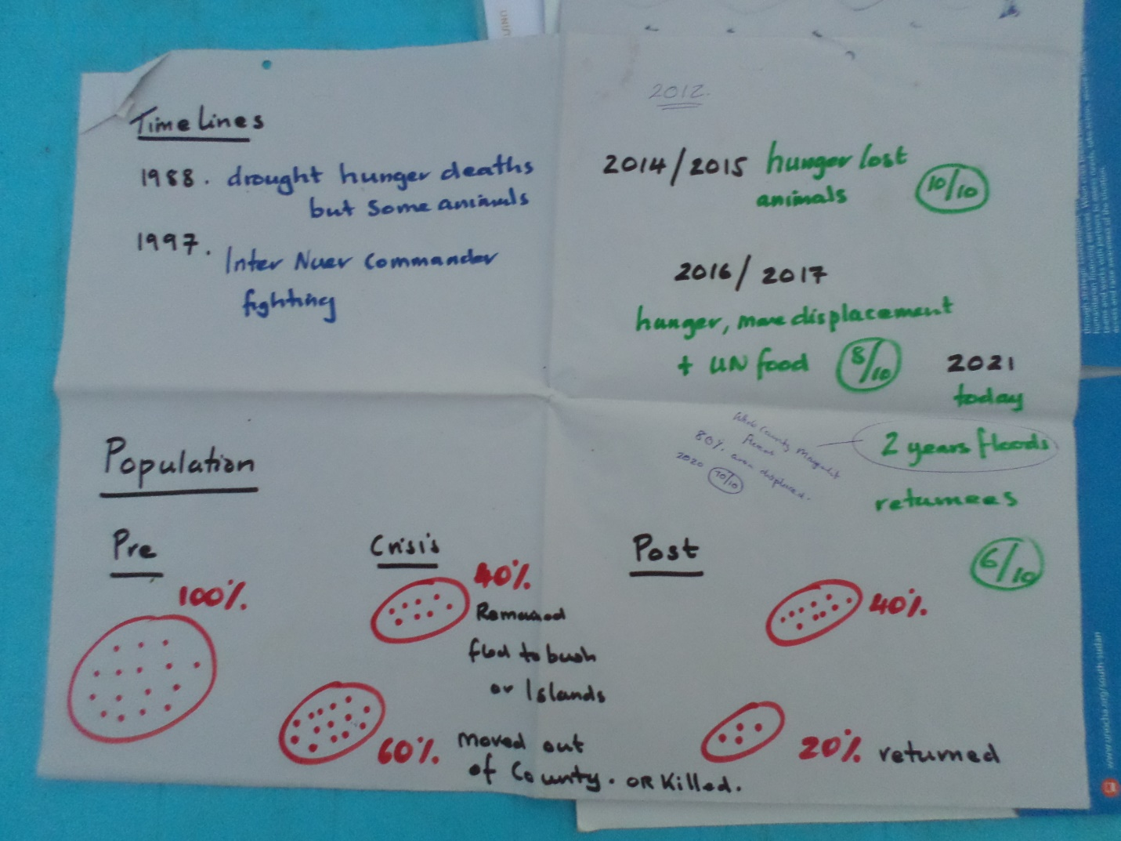

Across much of **Leer County** between 30 – 40% of the population remained at the start of the crisis; some killed, some died and others survived; returnees since 2019 range from 12 – 30%; and in addition since late 2020 there have been a further new influx of IDPs from especially Mayendit.

Across **Mayendit County** the situation is similar in that 30 – 50% of the population remained; especially from Mayendit South who brokered a peace with the SPLA/ Youth militia and were also able to salvage many of their livestock avoiding the worst of the human rights violations. In Rupkuai 50% are perceived to have returned but 30% of them subsequently returned to Juba, Khartoum and the POCs due to hunger and the pressure on their hosts/ relatives/ friends to share their existing minimal resources. In other locations consistently 20% have since returned but with significantly more IDPs in Mayendit than in Leer due to the effects of flooding: 25% from within the same Payam; and 20% from Mayendit South and parts of Panyijar.

There is an noticable lack of male labor in the communities (for farming & fishing; with wild food collections purely female prescribed); on investigation many were killed (more than women & children who were also brutally killed). From two communities: 20% based in the cattle camps; 30% displaced during the crisis & yet to return or killed; and 50% within the Payam (around the homesteads cultivating, mending dykes (30%) and others with or without jobs in the market (20%)). Shortage of labor is a major constraint to highly vulnerable/ poor families to sustain their livelihoods (see later case studies).

**Ranked problem & solutions (vision of the future)**:

**Ranking shocks & challenges:** Women in Leer ranked equal highest the hunger and water collection (10/10); followed next by ‘youth with guns’: issues around pregnancies, looting (criminality) & cattle raiding (8/10); with health, flooding (location specific) and high food prices scored far lower. Men in Mayendit however: overwhelmingly ranked floods as #1 (given the extent and disproportionate effect in this county); and with hunger #2, food prices #3 and insecurity & cattle raiding #4. In the eleven days of the mission two raids took place in Thonyor (Leer) & Laeh (Mayendit) – no details elicited.

**Future vision (from men, women & youths):** need for national level togetherness and unity with soldiers going back to work (maintaining rule of law or returning to assist their communities); since independence people see a lack of leadership & direction; especially poor people want to ‘send their children to school’ in the hope they will come back to do something in their communities; but some degree of despondency that they do not believe their Government is able to bring peace & stability.

**Shocks across Leer & Mayendit**:

The **lasting effects and culture of conflict**: evidenced in the impoverishment of the social groups in each community; the loss of labor, livestock and other property and assets; conflict being politically motivated; a culture of ‘taking wives’ and resources sparked by the inter Nuer commander conflict of 1997 and the establishment by the Sudan PDF of the Nuer militias: heavily armed with instructions to loot ‘cattle & girls’ and continued by both sides in the current National crisis. Reference the Amnesty International report[6]: ‘Anything that was breathing was killed’ (2018) which described and documents the deliberate destruction of livelihoods, burning cereal stores, tukuls, the rape and brutal murder of children & babies; and especially the killing of men.

Key illustrative examples taken from the Amnesty report include:

* Systematic sexual violence aimed to “*demonstrate power over victims, impose extreme humiliation, destroy dignity and to fracture families and community through the stigma and shame attached to survivors”*
* Attacks on villages using hunger as a weapon of war through attacks on the sources of food, cut down fruit trees, mango and banana trees up-rooted, burnt homesteads & grain stores, searched out cattle camps and migration routes.
* The patterns of violence indicate a consistent failure to address violations and abuses;
* UN commissioner on human rights (Feb 2018): ‘*leaders show a grave lack of accountability for gross human right violations since 2013; and a marked lack of political will to do anything; with many of the key players implicated’*; later in August 2018 President Kiir issues a ‘general amnesty’!

**Flooding 2019/ 2020**: especially across Mayendit (see map); people forced to come together in confined upland (‘highland islands’) areas;

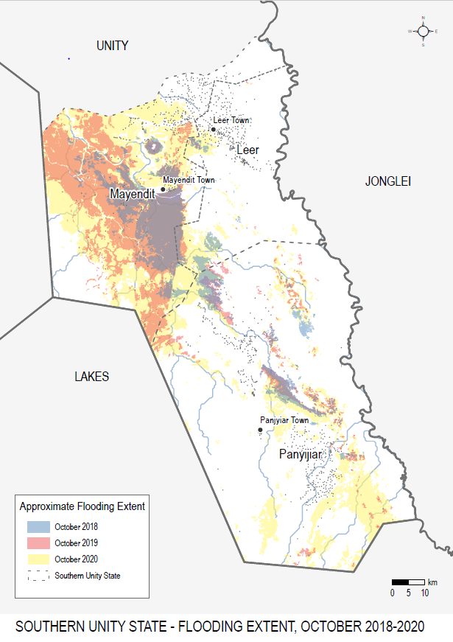

* Dykes rehabilitation neglected over past 7 – 8 years; committees established; maintenance active in Dabluai (Mayendit) & Thonyor (Leer): work groups team leaders operating on alternate days 8 am - 3 pm in Thonyor since March, strengthening & raising the height of dykes; pre crisis (Padeah) annual repair of the dykes along River Jaap; past 8 years of crisis the dyke repair & maintenance abandoned; post crisis re-started the communal repair work;
* Harvests in 2019 39% of ‘normal’ but 2020 harvest zero produced and displacement by 80% of the population; with flood affected IDPs from South and Western Mayendit in five locations (Mayendit County): Laeh, Rupkai, Dabluai, Thaker & Tutnyon; and in two locations (Leer County): Thonyor and Leer town;
* Floods unprecedented in 2020; last seen 60 years ago; Panyijar swamp overflowing due to rain & R. Nile water levels rising August – October; normally recede after October but not in 2020 with widespread destruction of crops;
* Positive effect of floods: vegetable production and river fish now found in the swamp;

Just as the crisis effected the social groups so the flood has had a devastating effect on people’s resilience, assets and livelihoods as depicted by chiefs and officials in Mayendit leaving ever more people impoverished, hungry and poor. Livestock numbers were generally higher during the crisis as compared to the losses experienced in Leer until the flood of 2020.

**Effect of flooding on social groups & livestock** (% piling exercise with chiefs and County officials in Rupkuai):

|  |  |  |  |
| --- | --- | --- | --- |
| **Social groups** | **2019** | **2020** | **Comment** |
| **Rich**: Riang riang | 35% | 10% | Many more livestock in 2019 |
| **Middle**: Ney tin te tah | 35% | 13% | Livestock disease & starvation reduced animals during the flood |
| **Poor & extreme poor**: chan & changi | 30% | 77% | Further increase in the poor groups |

**The micro economic & household level consequences of the macro economic crisis**: sorghum is too expensive for most households to purchase;

A depressed market limited by **depressed demand** from poor consumers with very limited ability to generate income without capital: money or livestock; limited range of commodities at village, Payam or town level. Exceedingly high prices: 1,600 – 2,000SSP (approx.. US$4) for one Malwal of sorghum; a bottle of fruit juice 1,000 SSP (approx.. US$ 2); markets supplied from Juba (with source markets in Kenya & Uganda with supply chains affected by the indirect effects COVID); affected by the currency devaluation and high levels of inflation since 2016; and transported by river through Adok port.

**Returns to labor** are low across the region: ‘mudding’ a house or roofing for one day’s work for 500 SSP; collecting & selling firewood for 300 SSP (a commodity often greatly over supplied at the market); for some the sale (rather than consumption) of green vegetables; or the sale of cattle or small ruminants but limited to those few who have. Poor households limited to selling firewood, cutting construction poles, making charcoal; and even buying milk at the cattle camps and re-selling in the main urban markets of Leer & Rupkai (for some this is a 6 am start & returning by 8 pm) … always ‘footing’ & carrying loads. There is plentiful supply of swamp reeds which are excellent for fencing but this requires a number of persons to both collect and carry (using human draft power); these large bundles sell for 1,500 SSP: used locally, sold at large urban markets and exported from Adok along the river to meet urban demand in Juba and elsewhere.

**Food security & livelihoods**:

A **normal meal pre crisis** is quite different from what is currently eaten today. Three meals for most (never the extreme poor at any point in time) included goat & cows milk in the morning; the sorghum based ‘walwal’ with milk and for those many better off either fish or meat; and for the evening kizira (Sudanese flat ‘injera’ type pancake made usually from sorghum) and for those more resource rich households (the majority) eaten with fresh fish, dried fish or meat; and with assorted dishes from maize, beans and vegetables such as okra. More plentiful and diverse.

During the crisis there was famine and starvation (trauma, hunger & disease related deaths reported) with a reliance on fish and wild foods (especially water lilies from the swamps around the ‘safe havens’ in the islands). Today the consequences of the conflict have maintained a deep hunger due to loss of resources and general impoverishment: one meal per day is the norm; where possible walwal & dried fish; “the war destroyed everything”; most in the now majority extreme poor social groups go the whole day without eating with minimal access to sorghum and a high reliance on wild foods. The more resource rich households may eat twice, have access to milk, may be able to sell an animal and better access the market (financially). See the table below showing food sources by proportions:

**Proportional piling of food sources**: *(proportions generated by % piling & illustrated below)*

|  |  |  |  |  |
| --- | --- | --- | --- | --- |
| **Source:** | **With UN food**  **(Dabluai returnee)** | **Without UN food**  **(Dabluai returnee)** | **Vulnerable HH**  **Gangyang** | **Comments**  **Ganyang** |
| UN food | 20% | Zero | 12% | Very small for 10 persons 6 registered |
| Market | 35% | 35% | 10% | People not buying the firewood over supply at market |
| Wild foods | 45% | 65% | 37% | Each day collecting |
| Relative & friends | - | - | 42% | Immense reliance on external support with sorghum |
| Harvest 2020 | 0 | 0 | 0 | Flood affected |

Together with the household level case studies this exercise demonstrates four **key features of vulnerability and poverty**: (1) people’s immense strength and resilience; (2) the unbelievable generosity and support of poor neighbors through sharing; (3) the importance and reliance of wild foods in keeping people alive; and (4) explodes the myth of aid dependency, at least by the poor and extreme poor living outside camps.

The two case studies below illustrate the distinguishing factors affecting the degree of vulnerability: available labor, and lost access to milk and animals. Everyone is either supporting returnees and/ or IDPs.

|  |
| --- |
| **Case study: vulnerable host with IDP** (Dabluai): family 11; 5 adults (2 elderly & 1 disabled) & 6 children; sister IDP from floods since August 2020; Changi because two adult men killed in crisis; ‘many HHs like this in Dabluai (maybe 20 – 30, does not really know exactly); reliance on wild foods (lalop tree in the compound), no cattle, no access to market (as no IGA), UN food 3 months ago; no harvest in 2020; lacking kinship support (used to be available); crisis a leveler: no hunger courts; elderly grandmother remembers them from 2001; everyone is now poor especially after floods. **HHS**: no food often (2); hungry at night sometimes (1); all day & night without food sometimes (1) = **phase 4**; high dependence on wild food collected by two adult sisters (both PLW: one lactating & other pregnant); has access to & knowledge of nutrition facility; |

|  |
| --- |
| **Case study: Ney tin te tah family with IDPs**  (Ganyang): two families living together; (1) husband & wife; 3 children at home; 3 older boys at cattle camp in Gandor (feed better than in homestead: milk & able to sell cow to support family (last happened in December 2020); (2) relatives IDPs from Panyijar then relocated to Jung due to floods since November 2020: husband & wife plus 3 children; no UN food as registered in Panyijar; **HHS**: no food (1); hungry at night (1); all day & night hungry (1) = **3 crisis**; |

The main **food sources** for the majority poor and extreme poor are ranked below:

1. **Wild foods**: generally lalop is used in the dry season (now exhausted); currently extensive use of palms: nuts, tubers and new sapling flesh; for the rain season (now) the focus is on water lily collection (illustrate with photos): a three day process: collecting, drying, removing the cover, pounding (removing coating), soaking and grinding for a ‘poshe’ type porridge; other leaves include *naquajok* leaves (infamous from the time of the 1988 famine); and kudra leaves. One respondent estimated she spent four days per week collecting wild foods:

|  |
| --- |
| **Case study: IDP living with host relative** (Kuot): young lady with three children, IDP from Mayendit South; arrived November 2020; lost 15 goats en route; husband back and forth in Mayendit South as registered there; stays with friend in Kuok; supports by selling firewood & vegetables to buy sorghum; **4 days per week collecting wild food**; HH 12 persons (5 registered); **HHS**: no food (rare/ sometimes) especially before ration collected; go to bed hungry (rare/ sometimes) as support from neighbor; whole day & night without food (rare/ sometimes) = **phase 3**; |

1. **Sorghum**: most host community members registered before October 2019 receive ‘UN food’ which equates to a **50% ration covering 2 months** and usually fully utilized after 5 – 10 days depending on the number of extra non registered persons to share with; for example the family on the outskirts of Rupkuai feeding 8 persons but only 3 are registered; the alternative is to carry out income generating activities e.g. collecting firewood or poles for sale in exchange for sorghum currently costing 1,600 SSP per malwal; cereal harvested in 2020, due to flooding, across Mayendit were largely zero; and across Leer somewhat better in locations less flood affected;

|  |
| --- |
| **Case study highly vulnerable family** (Ganyang): 10 persons in family; father in Bentui (temporarily), 2 elderly, 3 adults & 5 children; youngest daughter in the nutrition facility; knows two others in her village; six out of ten persons registered with UN for food; **HHS**: no food (2); hungry at night (2); hungry all day & night (2) = **6 catastrophe** (severe phase 5 extreme hunger but no starvation);  **Labor profile**: wakes at 5 am; early start if to sell grass/ firewood at market or attend clinic / nutrition facility (no service later in day); each day collect wild food approx.. 40% of food supply (children go if other tasks required); cultivates farm with elderly women; food preparation: 1pm (no one will eat today); try to collect grass to sell in market; highly dependent on two women & father (currently away). |

1. **Fish**: relatively few persons appear to fish given the observations of fresh fish being caught and the widely available dried fish at all markets from Adok to County towns to Payam and even Boma village markets; the reasons given are a lack of knowledge, expertise and fishing equipment (hooks, nets and especially boats to catch the river fish) and the fear of crocodiles and hippos in the remoter locations; women & girls labor profile would suggest they do not have the time nor the prescribed gender role to do so; and as indicated earlier there is an absence of young male labor in the homestead communities (less a problem in the cattle camps). Fishermen in Adok & Thonyor report making far more sales of fresh & dried fish to better off customers.

**Humanitarian Food Assistance (HFA**): the last Biometric Registration (BMR) of populations across the two counties took place in October 2019 which has excluded any new born babies since then, returnees and more recently flood affected IDPs. In Adok and Touchriak both communities estimated approx.. 35% of the current population are unregistered (returnees & IDPs) which puts significant pressure on the existing host population to then share the little they have. This is exactly what is happening from the case studies below:

|  |
| --- |
| **Case study 4 returnee** (Dabluai): from Khartoum family 5: husband, wife (pregnant), mother in law, 2 children; eat when food is available; ‘flood affected everyone’: loss farm land, lacking mosquito nets & plastic sheets; death of animals; those with animals moved to Laeh cattle camps reducing access to milk; No UN food; supported by those with UN food, wild foods & small garden; **HHS**: no food sometimes (1); hungry at night sometimes (1); whole day & night No (0) = **phase 2** (stress); capable wife & husband – there is labor with neighbor & relative support;  **Case study 2 returnee** (Kuot): young lady with two young children recent returnee from Khartoum lives in HH of 15; estimates 20% IDPs, 30% returnees and 50% host in Kuok; not yet registered; left in crisis as husband wounded (gunshot) and needed specialist health care in Khartoum; **Push factor**: tough life in Khartoum cost of living and no support; **Pull factor**: being back home & planted sorghum; supported by relatives; **HHS**: without food (often); go to bed hungry (rare/ sometimes); whole day & night without food (rare/ sometimes) = **phase 4**; big support from relatives & neighbors; |

The numbers of returnees and IDPs across the two counties are significant (estimated by stakeholders at 20 – 35% varying by location). On our last field day in Thonyor we understood that new BMRs by IOM were being finalized and some returnees reported they expected to receive HFA in the next 60 days having now been registered. The hunger and food insecurity had certainly increased over the past 18 months due to the added pressure.

Other issues experienced included: the long distance travelled with the wider threat of criminality and cases of women having their ‘UN food’ rations stolen on their return journey; one women registered in Mayendit South has a 30 hour walk (one way) to collect her ration; the change in 2019 from a 45 day to a 60 day cycle experienced as a reduction in ration size; periodic pipeline breaks; and suggested government tax (oil & beans later found in the market) estimated to be approx.. 10%.

**Perceptions of child malnutrition**: Dabluai: 2011/ 2012 women confirm at the time of independence ‘eating well’; good harvest, no crisis or flood; no raiding and many had cows. Approx. 35% children they recalled were malnourished; of those many were single women HH, no father, no cows, no farm/ gardens; or those with large extended family but with insufficient food resulting in hungry children. Health facilities were available then but no Nutrition services.

**Post crisis & floods**: the malnutrition situation has understandably reversed:

|  |  |
| --- | --- |
| **35% HH without malnourished children** | **65% with malnourished children** |
| 2 meals per day; 10 am milk; 7 pm milk;  Sorghum exchanged for milk at the market; local fish caught or purchased; dried fish & dried okra from market;  Rain season: kudra from the forest;  Dry season: lalop, palm fruit, tubers & coconut;  *Even better off families have children in the nutrition facility; more then to do with care giving practices & IYCF/ hygiene practices etc. than wealth & access/ availability of food.* | Only once per day (sometimes not at all – see case studies);  Water lilies & ‘nep’ palm tubers;  Without milk and regular cereals;  Might buy in market if poles to cut;  River & swamp nearby but not everyone who can fish; |
| **Of the 65%:**   * **30%** malnourished children; but better off than some; * **35%** exceptional poor/ hungry: no one to collect wild foods; no one working or a business person; friends & relatives do not have much; can only give them little; |

**Vulnerability & coping**: High reliance of poor/ extreme poor on wild foods; use of palm, collect firewood & fencing materials for sale (Adok); if host then access to UN food; no indication of remittance from outside except sometimes to ‘take a child’ for support; lost all property & assets in the crisis (cases of losing male labor killed in war); shortage of cash, blankets & mosquito nets etc. No food in storage and not knowing where the next meal will come from. Other poor families with disabled/ elderly unable to work; no father (many died) to labor or farm.

|  |
| --- |
| **Case study** **vulnerable host** (Rupkai): elderly lady with two young children; WFP ration but mainly wild food collection (palm nuts, tubers & ‘kudra’; plants small vegetable plot; sorghum last 6 – 7 days (10% of a 60 day ration); interesting IGA sells sugar for businessman in small bags & keeps the profit (highly exploitive for poor people but they can only afford small quantities); **HHS score 3** (crisis levels of hunger): without food in the house (sometimes); go to bed hungry at night (rare); no food whole day & night (rarely) – she would borrow or beg from neighbors; |

Can Amanya use this?

**Health**: lack of availability of medicines (Adok) plus hunger; when no medicines then use neem tree leaves; PHCU & Nut facility – not enough medicines; more serious send to Leer or even MSF will then send onto Bentui; some use of neem tree leaves for malaria, diarrhoea & as an eye wash (Touchriak); Rupkai clinic 1 hour walk if sick (otherwise youth carry on poles); NGO run; not always medicines: malaria & typhoid; no use of traditional healers; people many capacity of clinic small; plenty cases of children vomiting & diarrhoea, flood/ rain season induced (Rupkai);

**WASH**: Boreholes for drinking water but insufficient capacity (long waiting times) so alternative is the river (Adok); nine villages but only 2/3 boreholes functional; alternative is river side 30 mins each way; #1 problem for women!! (Touchriak); increase in diarrhoea cases; open defecation (especially children) washed into poor hygiene home environment; water about 10 mins away but demand > capacity waiting for 1 hour (Rupkai);

**Institutions**: Alex I will leave the section on institutions to you; this is what I have:

**Chiefs courts** (Alex); More fragmented communities; some communities stayed together & system of courts maintained; general undermining of the chiefs: by Elite politicians (over the years: ‘you flooded the place with guns’) and by Youth with guns; violent crimes killing/ rape & theft with threat of life by masked persons/ often at night; local institutions e.g. police unable to deter or detect; recent incident of Luak with animals burnt down! Chiefs without power at night;

**Dyke maintenance** active in Dabluai (Mayendit) & Thonyor (Leer): work groups 6 am to 11 am; organized by chief but not compulsory; crisis took away the Chiefs authority; with youth answerable to themselves (though supportive); passed forced measures by Government but lead to killings; chief unable to enforce;

**Hunger courts** (Alex): no mechanism for them to function in time of need; as no redistributive power or resources available to redistribute e.g. 2014/ 2015; 2016/ 2017 etc. times when all was lost e.g. cattle, businesses e.g. main business centre in Leer pre crisis (#2 in Unity State); lack rule of law: feeble state of rural policing (lacking authority & stature);

Pre crisis only supported relative with a cow or give milk; past relative obliged to support; not happening now; hunger courts last seen in 1988/ 1997; there is hunger (especially Mayendit due to floods) but no functional hunger courts as relatives do not have the resources to support (valid case for UN food); (Rupkai: vulnerable HH, FGD women plus local chief);

**Role of church & religious groups**: in local peace, mediation & dialogue (e.g. work of CH)

**Role of youth** with gun (highly visible in the towns and communities ….. mission to cattle camp on day 9; see below on women ranking exercise of community problems: pregnancies, looting/ criminality/ cattle raiding; youth ‘militarized’ with guns but suffering trauma, depression leading to pregnancies and conflict and criminality (Padeah); youth with ‘nothing to do’ in many places; but they do share the elders vision of the need for education; they have their own structure & leadership resolving matters around pregnancy with compensation (3 cows) and will decide on revenge attacks.

**Operational recommendations**:

*International community & donors*:

**“The crisis is better now but not over”: Social, psychological and economic effects of the conflict/ crisis remain**

1. Political will and leadership to address the Revitalized Peace Agreement constitute the integrated armed forces with the aim of enacting and enforcing the rule of law across Southern Unity with a comprehensive disarmament process;
   1. Commend the New Commissioner for removal of SPLA soldiers in 2021 off the street of Leer;
   2. but in addition to remove an ‘occupying force’ implicated in the human rights violations of 2015 and 2018 out of the two counties; which will allow residents of the TPA to return and along with traders to reclaim their land and property;

1. Address the human rights violations perpetrated during the height of the crisis:
   1. Advancing the peace process by establishing the hybrid court to attain justice, reconciliation and reparations in the form of concerted investment; and
   2. Ensure the establishment for the Commission for Truth, Reconciliation and Healing (CTRH);

*Immediate humanitarian actions*:

1. **Unregistered persons** for ‘UN food’ (often returnees & IDPs) to be registered (IDPs, returnees & new born babies) and for registered IDPs to be able to collect their food ration in their place of current residence (those from especially Mayendit South and Panyijar);
2. Immediate delivery of **main season response kits** addressing the coordination issues regarding seed distribution across both Leer & Mayendit (discussed at the FSL cluster meeting in Leer during the mission):
   1. Leer: Nile Hope to factor in existing ICRC main season distributions in Nguek, Norking and Bow; and
   2. Mayendit: Coalition for Humanity to factor in existing ICRC main season distributions in Thaker;
3. Replenishment of **livestock vaccination and treatment inputs** by FAO especially to address the Foot & Mouth Disease (FMD) issue which has devastating effect on reducing milk production;

*Longer term resilience building*

1. Explore with partners the establishment of **community self help groups** (for poor and extreme poor family members) and factoring in the shortage of time and labor that these households lack; innovations that are labor saving in any way to be prioritized;
2. Explore with partners initiatives with **youths (male and female), skills training and wider education** to support their own vision for a better, more peaceful future;
3. Explore with partners support to **adaptive livelihoods** in the absence of males to promote knowledge, skills, inputs/ assets for fishing for home consumption and for the market; likely that other options are open in this area (follow up with FAOs alternative livelihoods with agro pastoralists);
4. Explore with chiefs and local communities (and partners) on ways to support and sustain dyke rehabilitation: support community initiatives to strengthen and repair & maintain community flood defenses possibly through the sensitive deployment of FFA/ FFW/ CFW;

Anything else including the kitchen sink?

**Annex 1: assessment mission itinerary**

|  |
| --- |
| **Day 1**: travel Juba – Mayendit – Leer; set up at CH compound   * Rumbek: participants form the re-convening of the 1999 Wunlit peace agreement; GOSS, RVI and AMA (lady from Yambio & James from Leer/ Pilling): #1 string message about peace v conflict * Meet with Area Commissioner (Stephen) & RRC (Paulino); FSLC partners: CH, NH, VSFS; others to meet: ICRC & NRC (WFP GFD partner); * Meeting with NGOs (Alistair on **context**) and Chiefs, mix male & female (Alex on social dynamics) 2 – 5 pm; |
| **Day 2**: remaining in Leer town with key stakeholders before 6 days of community meetings;   * Meeting with NGO KIs to develop the social analysis across three time periods: pre/ during & today during the crisis; and comparing coping strategies & vulnerability over time * Alex meets again with the chiefs to discuss the hunger courts and their role in coping strategies * FSL cluster meeting and mapping exercise to determine the functionality of FSL service delivery across Leer & Mayendit with: ICRC, NRC, NH, VSFS, UNIDOR & CH; follow up meeting with ICRC (completed) and NRC (KI unavailable); |
| **Day 3:** travel to Adok port (Leer) 45 mins;   * meet port officials & traders re: import & export trade routes; * meet with FSL IRNA tool: population change; meals/ sources; access to HFA; ranking hunger periods; Youth & hunger courts & other institutions e.g. police & chiefs courts; * travel to Touchriak (NH nutrition facility: rural focused FS assessment; social group analysis; health & WASH; HFA access; problem ranking from women perspective; |
| **Day 4**: travel to Padeah (Leer) 1 hour drive;   * met with elders, chiefs & deputy Payam Administrator: high level issues around peace & stability; functionality of local institutions; root cause of crisis: leadership lacking; power vacuum & gaps in local level institutions; * livelihood & flooding: before/ during/ after the crisis; dyke construction along R. Jaap; visit to market/ traders/ milk sellers from Laeh; return due to rains & CH compound flooding after start of rains 3 pm! |
| **Day 5**: travel to Rupkuai (Mayendit) 45 mins drive:   * meet with County Executive Director; women leader & six male chiefs & RRC; mid mission review & presentation: timelines/ population change/ social change & mapping trade routes with Mayendit adjustments; * FGDs with women using IRNA/ risk famine/ HHS tool; service functionality UNIDOR (Nutrition) & CAST (Health); supply route tool in Rupkuai market; |
| **Day 6**: Thaker/ CH WASH & SP (GFD Mayendit): initial on site planning (Thaker Payam);   * meet with SP on foot print, food assistance ration & extent of flooding; heavy downpour changed plans; FGD on the outskirts of Rupkai (host); * travel on to Kuok: initial planning with host re % of returnees & IDPs; then KI with returnee from Khartoum; and IDP from Mayendit South; |

|  |
| --- |
| **Day 7**: Dabluai & canoes/ flooding/ returnees, IDPs & vulnerability; % food & income sources;   * Travel to river/ swamp side; 2 hour walk to Dabluai en route discussions with middle HH on youth; * arrival & discussions with Chiefs & Payam officials on IDPs, returnees and flooding; FGD with IDPs on risk famine & HHS; KI with highly vulnerable HH & HHS; |
| **Day 8**: Thonyor cattle camp & NRC (GFD Leer); 6 am travel to cattle camp;   * 1 hour plus with elder (Michael), mother (Martha) and Mayendit South Chief (John) on food security; livestock & flooding; animal health; and * then with Payam officials on services (Amanya), market trade & security (Alex) and food security & flooding (Alistair). Meeting with NRC on WFP food caseloads & population numbers/ challenges for IDPs & returnees to access GFD.   Afternoon field note review & analysis; |
| **Day 9**: Final field mission: Laeh (Mayendit) – ½ day planned to wrap up any missing issues identified by Friday review; cancelled due to cattle raid from Koch youth on Laeh cattle camp(s);   * alternative destination then to Gangyang villages beyond Thakker: malnutrition & vulnerability focus;   Afternoon: interview with ODI consultant on IPC |
| **Day 10**: morning field note review & analysis; workshop & brainstorm with REACH colleagues; |
| **Day 11**: Report writing; debrief with Leer County commissioner;  Return travel to Juba from Padeah depart 1.25 pm; depart Leer by **10.30 am**; |

**Annex 2**: **FSL cluster basic coordination tools**

**Trends**:



**Gaps**:



**FSLC ranking based on IPC**:

|  |  |  |  |  |  |  |
| --- | --- | --- | --- | --- | --- | --- |
| **State** | **County** | **Phase 4** | **Phase 5** | **Total % in Phase 3+** | **Total Pop in Phase 3+** | **Priority** |
| Unity | Mayom | 30576 | 0 | 0.8 | 122303 | 1.3 |
| Unity | Panyijiar | 29276 | 0 | 0.8 | 93684 | 1.3 |
| Unity | Abiemnhom | 11119 | 0 | 0.75 | 41694 | 1.3 |
| Unity | Mayendit | 13815 | 0 | 0.75 | 51806 | 1.3 |
| Unity | Koch | 14439 | 0 | 0.7 | 67380 | 2 |
| Unity | Leer | 11365 | 0 | 0.7 | 53038 | 2 |
| Unity | Pariang/Ruweng | 25592 | 0 | 0.7 | 89572 | 2 |
| Unity | Guit | 13636 | 0 | 0.65 | 44316 | 2 |
| Unity | Rubkona | 66682 | 0 | 0.6 | 200047 | 2 |

**Annex 3: Two main livelihood zones across Leer & Mayendit:**

**NORTHWESTERN FLOOD PLAIN SORGHUM AND CATTLE (SS07)**

Livelihoods in this zone depend on a combination of crop production (sorghum is the staple), rearing of cattle and other livestock, fishing and hunting, and gathering of a range of wild foods and bush products, with the exact combination depending on the geography across the zone. The zone has a large population of cattle owned by an estimated 80% of households. For cereal, the zone is deficit producing, and imports a significant proportion of its staple foods from Sudan. In return, large volumes of cattle and other livestock are sold to Sudan.

The zone is characterized by expansive flood plains located in the lowlands of Greater Bahr el Ghazal region to the west of the Nile River. A single rainy season occurs from May to October (sometimes into November), with an average annual precipitation of 800 to 1100 mm. The dry period peaks from January to April when competition for water and pasture is critical. Natural vegetation varies from grasslands and swamps with papyrus reeds, to bush scrub and patches of forests. Population density is relatively high by South Sudan standards, and there are relatively high numbers of internally displaced people in the zone, spread across most of the districts (as of 2018).

The zone is a classic mixed, agro-pastoral production system. Almost all households, from poorer to better-off, are involved in cropping (exclusively rain fed) and rearing of livestock, and both components play a fundamental role in meeting food and cash income requirements. These two components are supplemented to a significant degree by fishing, hunting, and the collection of uncultivated native products and plants.

The main crop is sorghum, which, in addition to groundnuts and sesame, is the key cash crop grown. Maize, pearl millet, legumes, and vegetables are also grown (in order of importance). Livestock are very important assets in the zone and the main types are cattle, goats, sheep, and poultry (in order of importance).

Fishing is practiced by all households during the rainy season when the flood plain is inundated. A large array of wild foods[7] that are available at different times throughout the year and which, like fishing, constitute a normal component of the diet.

While livestock sales and crop sales, complemented by petty trade, are the main sources of income for better off households, poorer households rely on the sale of labor for cropping and livestock rearing, natural materials (grass, charcoal, etc.), fish and wild foods, sheep and goats, locally-brewed alcohol, and water to better off households. The poorest households with no cattle are often supported by better-off relatives, for example, in the form of gifts of sorghum, shared rearing of livestock, or access to a milking cow.

Seasonal migration within and outside the zone is common between January and June. Destinations include Sudan, Amiet, Wau, and Juba, and activities include on-farm and off-farm work (brick making, masonry).

Overall, the level of agricultural production is low. Possibly the largest single factor is that household labour needs to be shared between agriculture and livestock rearing, reducing the efforts allocated to growing crops. Additional factors include unreliable rainfall, long-term conflict and displacement, urban pull factors, limited access to fields that are located far away, and a lack of inputs.

Labor within the household, or the ability to rent labor through cash or in-kind payment, is the primary determinant of land size cultivated (large areas of land are not cultivated in the zone). Poor households cultivate up to 0.5 ha and provide labor for better-off households. They cultivate using hand tools only*,* and the harvest lasts for about six months during a normal year – but only between two and five months for the average household in the current context.16 Better-off households cultivate 2 ha or more, meaning they almost always hire the labor of poorer households. Cultivation is done manually for the most part, but also with ploughs and some machinery.

Cross border trade with Sudan is economically important. Sorghum constitutes one of the primary import commodities, along with other foods and fuel. Local livestock, tamarind and gum Arabic are sold to Sudanese traders. Primary market-linking roads within the zone are fully accessible during the dry season, but only partially accessible during the rainy season. Prices in key local markets including Kuajok and Aweil have seen large increases since 2016, including for key staples such as maize, sorghum, and groundnuts. For example, prices of sorghum have increased nearly five-fold. At the same time, agricultural labor is an important source of income for poorer households, and wage rates have increased at a comparable rate.

Most of the zone has not been directly affected by the current conflict to a large degree. This means that the displacement of populations has been minimal, with better-off households remaining in place and able to employ poorer households. The exception is the south-eastern section of the zone (parts of Unity and Lakes States) where the levels of conflict and displacement have been notable. Some areas of the livelihood zone are affected by cattle raiding and conflict over pasture and watering points for livestock, most often in the dry season (February to May). Such conflicts are long-term, reciprocal in nature, and as much intra-ethnic as they are inter-ethnic. The result of these types of conflicts is that agriculture and livestock rearing is disrupted, leading to lower productivity. It is possible that the elevated level of conflict over and above the long-term level of conflict has put an additional strain on labour availability, with men involved directly or avoiding involvement by moving to urban centres, neighbouring areas within the country and to other countries.

**NILE BASIN FISHING AND AGRO-PASTORAL (SS08)**

This livelihood zone transects south to north almost the length of the country. It is located on and primarily defined by the Nile river. As in other zones, a combination of livelihood strategies is used, including fishing, cropping, livestock rearing, and harvesting of wild products. However, as a wetland defined by the Nile River, there is greater focus on fishing and river-based production than in neighboring zones located on the expansive flood plains to the east and west of the river.

The zone is a narrow band of swampy flood plain on either side of the river. Tall reeds and grasses such as papyrus, as well as bush scrub dominate the landscape. The soils immediately adjacent to the river tend to be high in clay, becoming more sandy loam further away from the river. Rainfall ranges between 700 and 1300 mm per year, falling in a single season from May to October.

Naturally-occurring resources are diverse: papyrus grasses (for making mats), fish, crustaceans, wild animals and birds, water lilies, foods including fruits, tubers, leaves, and honey, and gum Arabic, wood, etc. Reserves of crude oil are present in the zone. A diverse range of fish species exist, and fishing is an important component of livelihoods, especially for poorer households. Fishing remains artisanal for the most part involves the use of canoes, spears, and nets. The introduction of refrigerated carriers indicates a potential for increased exploitation. In addition to fishing, other common naturally-occurring foods fundamental to the food security of households include water lily and *lalop* (desert dates), as well as roots and tubers, vines, berries and fruits, leafy greens, honey, and game meat (e.g. *dik-dik*, antelope). Many of these can be processed for sale or later consumption and are considered an intrinsic part of normal livelihoods.

Rain-fed farming is practiced by most households. Sorghum is the primary staple grown. Other crops include maize, cowpeas, groundnuts, and vegetables such as okra and pumpkins. Most cultivation is done manually, although some better-off household use ploughs and machines. Cattle, goats, and sheep are commonly held by poor and better-off households. Livestock from other zones are brought in towards the end of the dry season for water from the Nile.

Production in the last four years has been disrupted due to the influx of displaced people (as of 2018) and the general effect of the conflict. The geography of the zone is challenging, meaning that households likely already have a high level of resilience and diversity of options, and disruption of one option might lead to an increased reliance on another. Normal vaccination campaigns by government are not currently active meaning an increase in incidence of livestock disease. There is a reluctance to cultivate crops, and fishing is periodically affected by conflict.

The zone is not known for an active trade and market system due largely to the logistical challenges of a wetland environment. Canoes and motor boats are the most common means of transport as road access to areas beyond the river is difficult and seasonally unreliable. Despite this, the zone is known as a thoroughfare, with five river ports (Malakal, Adok, Shambe, Bor, and Juba) critical for trade, and important for the lower levels of conflict typical in the area. Prices of key staples at Bor market have increased at a comparable level to other areas of the country, for example between five and seven times since 2016 for sorghum and maize. Livestock and milk products, fish, wild products such as desert dates, and cereals are sold here by local producers, while other commodities such as clothes and soap come into the area. Cattle, goats, and sheep are sold by farmers at Panyijiar, Awerial, and Ayod local markets for onward sale at the main livestock market in Bor.

**Annex 4: Social group analysis & change over time:**

|  |  |  |  |
| --- | --- | --- | --- |
| **Pre crisis situation circa 2012**  **Population approx... 130,000[8]** | **During the worst hunger 2015/ 2016/ 2018**  **Approx. 50,000** | **Situation today 2021**  **Approx. 80,000** | **Situation today 2021**  **Women FGD Touchriak** |
| **Rich:** riang riang 47%  Characteristics: 60 – 70 cattle even 100+ up to 500; goats 100+ up to 200 (not really considered)  With money, Government job, salary; sale of bulls; booming business: clothes & commodities; Leer #2 shopping center in Unity; multiple houses, multiple wife & farms: 5 – 10 bags sorghum per farm (some up to 10 wives); large families with labor; connections & family across SSD & overseas; | **Rich**: 0%  Lost cows; caught by surprise; shops & assets in Leer looted; but good coping: education, investments & family in country/ world wide; networks ‘large families in places’ and ‘children already outside the country’; big psychological effect to lose ‘everything’; 2 – 3 years wave of repetitive looting; **25% killed (trauma/ psychological);** 14% dropped to chan; 17% left country & 40% left for other parts of SSD. | **Rich**: 0%  New people rich but not like before; market traders Darfur, Ugandan & Nuer;  Population unsure: those moving back & forth (split families) from POC;  Stakeholders estimate approx... 16 – 20% spontaneous returns (see context on day 1) | **Rich:** 8%  Some have 10 cows & invested in the fencing export business in Adok;  Many from Leer moved to Touch riak where they remain today as fear of SPLA in Leer; |

|  |  |  |  |
| --- | --- | --- | --- |
| **Middle**: ney tin te tah 23%  Cows 10 – 15; goats 15 – 20; businesses, charcoal, shop, fishing, good farm: 3 – 5 bags (1 bag seed other last for 3 – 4 months); fewer wives; | **Middle**: 0%  As with rich some left country or displaced to POC; most fled to the islands; having lost their assets; Some with means found a way out e.g. bought a fishing hook (to fish); travelled to Nyal & onto Juba; and some killed; | **Middle**: New rich 10%  Cows 3 – 5; business: market, fishing (fisher folk climb up the ladder) & transport; money, resources, eating beyond HFA; children remaining in POC (Chief: education); NGO workers with salaries: big pressure to share with relatives; children also away (Juba/ POC/ Uganda etc.); Pre crisis 40 NGOs; today only 14; | **Middle:** 20%  1 – 2 cows; plus farm & goats;  Both rich & middle now have very little to share with their chan & changi relatives & neighbors; |

|  |  |  |  |
| --- | --- | --- | --- |
| **Poor**: chan 17%  Able to eat & survive; but not able to predict food source in future; 1 – 2 cows; some only goats & chickens; unable to make necessary social contributions to relatives’ dowry of blood money payment etc.; disabled (mental/ physical from poor group); migratory fisher folk[9] (‘smelling of fish’); fish business 🡪 buy cows, farm & pay school fees (some clearly Middle); | **Poor**: merged with extreme poor – 100%;  Some **killed others died of hunger in the “Buoth”** (Hunger);  ICRC last food drop July 3rd 2016; MSF, UNIDOR & NH mobile health; NRC & VSF national staff remained; WFP air drops once access permitted in Jan 2017 | **Poor**: 30%  Coping with HFA; those registered; fishing, forage, wild foods; able to buy a bit more; animals: 1 cow & some goats; sell wood & ‘kudra’ leaves’ | **Poor:** 27%  Have a very little to share BUT still share with their neighbors! |

|  |  |  |  |
| --- | --- | --- | --- |
| **Extreme poor**: changi 14%  Includes women HH; child HH; elderly HH that are isolated from their family and lacking kinship support; men who cannot marry (without cows); losses of assets/ money become vulnerable; | **Extreme poor**: joined by Chan & others  Coping on leaves; became fisher folk; water lilies & palm flesh/ tubers; all remained: some died other survived;  Crisis saw significant increase in female headed HHs; | **Extreme poor**: 60%  Those not registered; no animals; everyone fishes; returned but missed registration; left card in Bentui with family; mobility constrained; elderly & unable to get to registration in time; | **Extreme poor:** 45%  Minimal support; UN food for those registered; palm trees; fish from fishermen (ney tin te tah); collecting water lilies;  **See vulnerable case studies below** |

**Annex 5: Food security & livelihoods response**: For Amanya to use in section on service delivery; note number of NGOs pre crisis 40 as compared to 14 across the two counties today!

**FSL cluster meeting**: with NH, CH, VSFS, RRC, UNIDOR & ICRC; issues around gap analysis and the ‘actual’ or real population numbers; e.g. Leer County: IPC (76,000); WFP BMR (40,000) and recent IDPs (2020), returnees (since 2019) & natural growth more likely 60,000+; Mayendit County: IPC (69,000), WFP BMR (25,000 TBC).

**Main & Dry Season Response planning:** essential that scarce resources are not duplicated; mapping of targeted inputs suggest this may be the case without necessary adjustments to allocations & targeting;

|  |  |
| --- | --- |
| **Leer County** | **Mayendit County** |
| **DSR NH 2,000 HH – approx.. 12,000** | **DSR CH 3,000 HH approx.. 18,000** |
| MSR NH 3,092 HH – approx.. 18,500 | MSR CH 4,333 HH approx.. 26,000 |
| MSR ICRC 2,500 HH – approx.. 15,000 | MSR ICRC 1,200 HH approx. 7,200 |
| **MSR total: 33,500** | **MSR total: 33,200** |

**ICRC**: lead on flood response in Ganyiel & Mayendit; seeds & tools distributed early plus NFIs to returnees, IDPs and vulnerable unregistered families; promote ‘agro support’ and resilience with vegetable garden production around Leer (200 persons); livestock vaccinated limited to their 5 year planning locations with focus in Koch to 15,000 head; exploring micro economic initiatives for CAHWs (Vet kit & sales based on Mayom pilot vet drug store); assessment to take place on feasibility of CTP (cash programming).

**NRC** (WFP Leer IP): confirm blanket support for lean season; cycle reduced in 2019 from 45 days to 60 days (what people call the ration size reduction); knowledge of those who missed October 2019 BMR: returnees, POC & IDPs from Mayendit South & Panyijar; AAP/ CFM/ CRM rejected cards (Thonyor report new WFP SCOPE registration now accepted); need for extension of NRC Information, Counselling & Legal Assistance (ICLA) to support improved communication with communities on the question of registration.

Caseload 40,000 (alternate 27,269 and next month 12,664): Thonyor 14,146; Din Din 8,487; Padeah 13,123; Leer 4,178; IPC Pop WG = 75,000;

Additionally: African Indigenous Women Empowerment (AIWE): every 60 hours to 90 persons;

**SP** (WFP Mayendit IP): confirmed ration of 15 kg sorghum for 2 months; there are delays; essentially 7 kg per month (25% ration for an IPC phase 4 county with 75% IPC 3+); PMC & CFM in place at the four FDP sites; they are not getting the same level of feedback the assessment mission are receiving; confirmed the ration was reduced in 2019 (shift from 45 day to 60 day cycle); BMR indicates total caseload of 25,000 persons (last registration in October 2019) compared to pre BMR caseload 53,000 (thought to be many double collections) and IPC population WG estimate 69,000; pending IOM BMR to finalize numbers (finalized in Thonyor during mission with inclusion expected in the next distribution).

Caseload: 18,500 (alternate 12,472 and next month 6,011);

Based in Mayendit since 2014; many NGOs evacuated 2014/ 2015 and SP moved south to Mayendit South continue to deliver essential services: food, WASH, livelihoods (veg & fish kits and some crop kits) and nutrition. Mobile support from south. See worst recent time as 2018 when SPLA push to capture as much territory before the September peace agreement: raping, killing to push out iO. An occupying force still based in Leer.

**Coordination**: MSR (seeds & tools – see mapping for Leer & Mayendit): SP, ICRC and CH – review map for areas of concern; Monthly humanitarian coordination forum chaired by UNIDOR; other sector forums: WASH, Health & Protection; need for regular FSL forum to be chaired in Leer by CH (names & contacts for the national mailing list);

1. A score of zero being famine/ catastrophe like conditions; and 10 being fully food secure (3 meals per day, quantity, quality, diversity etc.);
2. The former livestock auction has yet to be revived in Leer town; along will all other infrastructure destroyed by the SPLA;
3. FMD Foot and Mouth Disease;
4. Pre crisis population of Leer estimated to being 100,000+ to as high as 170,000;
5. Some in fact not poor but tarnished by the prejudice of fishing;
6. [**https://reliefweb.int/sites/reliefweb.int/files/resources/ANYTHING%20THAT%20WAS%20BREATHING%20WAS%20KILLED%20%28AFR%2065.8801.2018%29.pdf**](https://reliefweb.int/sites/reliefweb.int/files/resources/ANYTHING%20THAT%20WAS%20BREATHING%20WAS%20KILLED%20%28AFR%2065.8801.2018%29.pdf)
7. including honey, wild shea butter, game meat (e.g. antelope, gazelle, wild pig, warthog, impala, rabbit, and *peer*), grains and seeds (e.g. *akuadha, goor, kuel*), tubers and other roots (e.g. *kei, acuech, leeth, athon*), tamarind, mushrooms, leafy greens (e.g. *nguit, annet, abyei, akuar, yinthou, apoor-monydit, abuthguk, alongkoi*) and coconut and other fruits (e.g. *apam, lang, milat, thou, apor, gumeel, coom, kurnyuk, kuec, ngap, lulu and akondok*).
8. Pre crisis population of Leer estimated to being 100,000+ to as high as 170,000;
9. Some in fact not poor but tarnished by the prejudice of fishing;