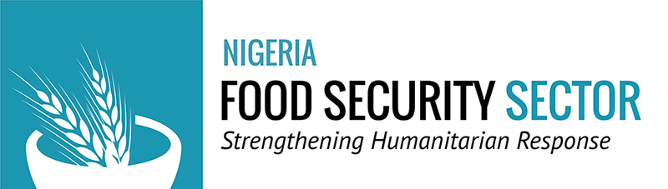
DRAFT AGENDA FOR BORNO FSWG MEETING OF TUESDAY 28th MARCH 2017
Venue: Conference Hall, Borno State Ministry of Agriculture and Natural Resources, Maiduguri.
Time: 10:00am
Agenda
- Welcome, Introduction and Opening Remarks
- Cadre Harmonise March 2017
- Presentation of results
- Discussion on the response plan
- Update of the Food Security Sector response on the fire in Konduga
- Sensitization
- Sector request of inputs, more collaboration and timely actions (respect of deadlines and provision of inputs on the FSS documents, 4Ws matrix and other inputs request)
- Regular update of the Financial Tracking System (FTS)
- Mini coordination
- Presentation of February Gap analysis and partners presence map
- A.O.B

