FOOD SECURITY COORDINATION MEETING
BOLORI II
April 19th, 2017, PUI Office, Maiduguri

- TRADITIONNAL ORGANSIATION OF BOLORI II WARD
Bolori II Ward is composed of 9 areas officially accepted by the local authorities and headed by a Lawan: Bolori 2, Bolori 3, Bolori 5, Bolori 6, Bolori 7, Bolori 8, Bolori 9, Bolori 10 and Bolori 11.
Based on the figures shared by the Lawans and Bulamas, 196,459 individuals are living in Bolori II Ward, including 105,155 host communities and 91,304 IDPs.
The list of all the community leaders (including Lawans and Bulamas) is attached to this minute:
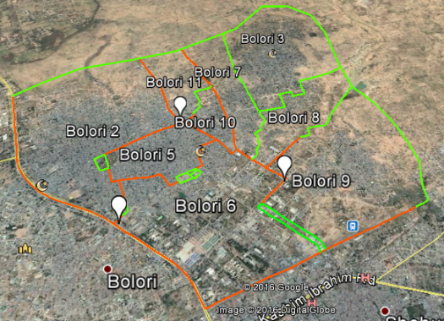

Fig 1: Bolori II Ward, Lawan’s areas

- HUMANITARIAN RESPONSE: ACTORS’ COORDINATION
As of March 2017, 4 actors are implementing food assistance and 2 actors are implementing BSFP in Bolori II:
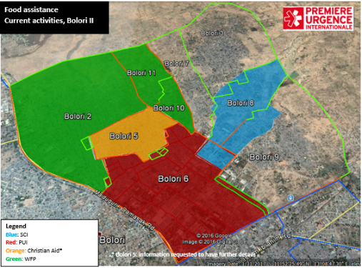
Fig2: Current Food assistance actors in Bolori II
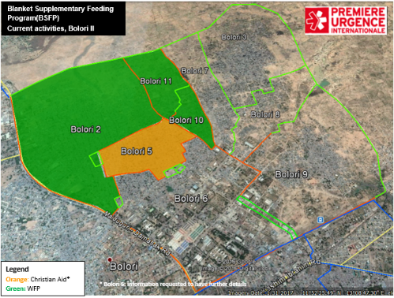
Fig3: Current BSFP actors in Bolori II
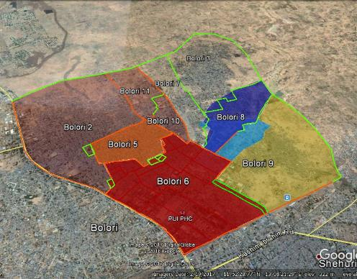
LEGEND
Blue: SCI
Dark Blue: SCI Projection for 2017
Red: PUI
Transparent Red: PUI 2017 projection
Orange: Christian Aid
Yellow transparent: ZOA 2017 projection

Food assistance
Projected activities, Bolori II
Fig4: Projections food assistance in Bolori II
In the coming months, both PUI and Save the Children intend to extend the food assistance. Moreover, ZOA is planning to start food security activities in Bolori II (Bolori 9).

- FOOD SECURITY ACTIVITIES
WFP is currently conducting monthly in-kind targeted distributions in Bolori 2, 10 and 11. It is acting as Gap filler until PUI starts the food assistance activities in those areas
Save the Children intends to scale up its activities to Bolori 3 and 7. Before the beginning of its
As of today:
FOOD E-VOUCHER | Save the children | Bolori 8, Bolori 6
 | PUI | Bolori 6
IN-KIND DISTRIBUTION | Christian Aid | Bolori 10, Bolori 11 and Bolori 2
 | WFP | Bolori 5

In the coming months:
FOOD E-VOUCHER | Save the children | Bolori 8, Bolori 6
 | PUI | Bolori 6, Bolori 2, Bolori 10, Bolori 11
 | ZOA | Bolori 9
IN-KIND DISTRIBUTION | Christian Aid | Bolori 5

In Bolori II Ward, the objective is to harmonize the response as much as possible and to set up a global coverage over the Ward including food assistance, BSFP as well as soft nutrition activities (sensitization, screening and referral, mother care groups, etc.).

- GAPS AND OVERLAPPING
As of April 19th, 2017, two areas (Bolori 3 and 7) shall remain uncovered.
Bolori II - GAPS and OVERLAPS
Food security
Communities | FS Actors | Gap/Overlap | Comments
Bolori 2 | WFP then PUI | / | WFP as gap filler until start of PUI activities
Bolori 3 |  | Current gap | /
Bolori 5 | Christian Aid | / | /
Bolori 6 | PUI, SCI | / | Coordination for Arab site 1 community
Bolori 7 |  | Current gap | /
Bolori 8 | SCI | / | /
Bolori 9 | ZOA | Current gap | /
Bolori 10 | WFP then PUI | / | WFP as gap filler until start of PUI activities
Bolori 11 | WFP then PUI | / | WFP as gap filler until start of PUI activities

The Bolori II 4W updated attached provides more details for a better coordination.

- LIST OF PARTICIPANTS

SN | Name | Position | Organization | Email | Phone
1
2
3
4
5
6
7
8
9
10
11
12
13
14
15

