FOOD SECURITY COORDINATION MEETING
BOLORI II

March 16th, 2017, PUI Office, Maiduguri

- TRADITIONNAL ORGANSIATION OF BOLORI II WARD
Bolori II Ward is composed of 9 areas officially accepted by the local authorities and headed by a Lawan: Bolori 2, Bolori 3, Bolori 5, Bolori 6, Bolori 7, Bolori 8, Bolori 9, Bolori 10 and Bolori 11.
Based on the figures shared by the Lawans and Bulamas, 196,459 individuals are living in Bolori II Ward, including 105,155 host communities and 91,304 IDPs.
The list of all the community leaders (including Lawans and Bulamas) is attached to this minute:

Fig 1: Bolori II Ward, Lawan’s areas

- HUMANITARIAN RESPONSE: ACTORS’ COORDINATION
As of March 2017, 4 actors are implementing food assistance and 2 actors are implementing BSFP in Bolori II:
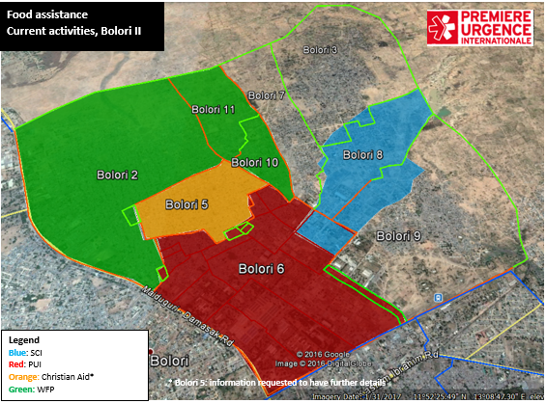
Fig2: Current Food assistance actors in Bolori II
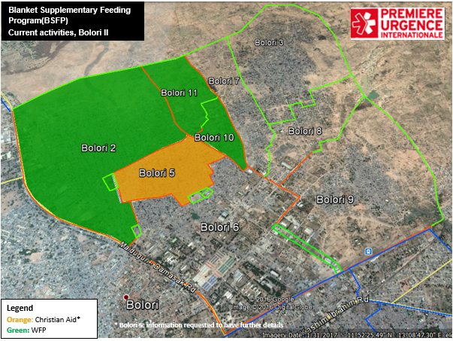
Fig3: Current BSFP actors in Bolori II
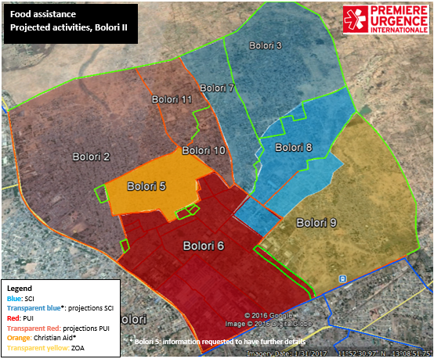
Fig4: Projections food assistance in Bolori II
In the coming months, both PUI and Save the Children intend to extend the food assistance. Moreover, ZOA is planning tol start food security activities in Bolori II (Bolori 9).
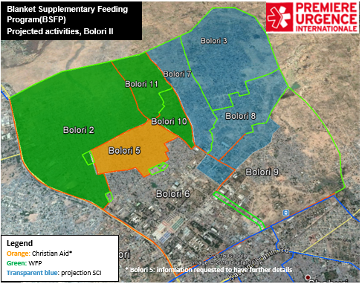
Fig 5: Projections BSFP in Bolori II

- FOOD SECURITY ACTIVITIES
WFP is currently conducting monthly in-kind targeted distributions in Bolori 2, 10 and 11. It is acting as Gap filler until PUI starts the food assistance activities in those areas
Save the Children intends to scale up its activities to Bolori 3 and 7. Before the beginning of its
As of today:
FOOD E-VOUCHER | Save the children | Bolori 8, Bolori 6
 | PUI
IN-KIND DISTRIBUTION | Christian Aid | Bolori 5, Bolori 10, Bolori 11 and Bolori 2
 | WFP

In the coming months:
FOOD E-VOUCHER | Save the children | Bolori 8, Bolori 6, Bolori 9, Bolori 3, Bolori 7, Bolori 2, Bolori 10, Bolori 9
 | PUI
 | ZOA
IN-KIND DISTRIBUTION | Christian Aid | Bolori 5

In Bolori II Ward, the objective is to harmonize the response as much as possible and to set up a global coverage over the Ward including food assistance, BSFP as well as soft nutrition activities (sensitization, screening and referral, mother care groups, etc.).

As of March 16th, 2017 and based on the information from the 4W, a deep coordination is requested in the following areas.
Bolori II - GAPS and OVERLAPS
Food security
Communities | FS Actors | Gap/Overlap | Comments
Bolori 2 | WFP then PUI | / | WFP as gap filler until start of PUI activities
Bolori 3 | WFP then SCI | Current gap, potential overlap | WFP as gap filler until start of Oxfam or SCI activities
Bolori 5 | CA | / | /
Bolori 6 | PUI, SCI | / | Coordination for Arab site 1 community
Bolori 7 | WFP then SCI | Current gap, potential overlap | WFP as gap filler until start of Oxfam or SCI activities
Bolori 8 | SCI | / | /
Bolori 9 | ZOA, SCI | Current gap | /
Bolori 10 | WFP then PUI | / | WFP as gap filler until start of PUI activities
Bolori 11 | WFP then PUI | / | WFP as gap filler until start of PUI activities

The Bolori II 4W updated attached provides more details for a better coordination.

- LIST OF PARTICIPANTS

SN | Name | Position | Organization | Email | Phone
1 | Amelie d’Hautefeuille | Field Co | PUI | / | /
2 | Anais Guerin | Food Security PM | PUI | mai.pm.fs@premiere-urgence.org | 09023382220
3 | Maxime Banchereau | Field Co | PUI | Mai.fieldco@premiere-urgence.org | 07016488803
4 | Mohammed Aji | Food security DPM | PUI | mai.dpm.fs@premiere-urgence.org | 08129425381
5 | Elicia Robertson | PM | Christian Aid | ERobertson@christian-aid.org | 09060348384
6 | Nicola Marcato | Area coordinator | COOPI | Areacoordinator.nigeria@coopi.org | 08120380277
7 | Andrabaryu Thlama Maigana | Team leader | IMC | andrathlama@yahoo.fr | 08133368965
8 | Aboubacar Guido | Program Officer | WFP | aboubacar.guindo@wfp.org | 09076710196
9 | Ayii Akob | Program | WFP | Ayii.akob@wfp.org | 09072620020
10 | Marco Falcone | Program off | FAO | Marco.falcome@fao.org | 09074009064
11 | Damilola Kudomi | APO | FAO | Damilola.kudomi@fao.org | 08029059132
12 | Lucie Odile NDiong | Prog advisor | FAO | lucieodilendiong@fao.fr | 09070251927
13 | Andrew Simba | FFP-Div | SCI | asimbwa@savechildren.org | 08168115250
14 | Kasim Yusuf | FSL officer | SCI | Yusuf.kasim@ savechildren.org | /
15 | Sylvie Michaud | PC NSFF | MSF-FR | msff-borno-pc@paris.msf.org | 08139745734

